Year 3 Science Knowledge Organiser Autumn Term 1
CHEMISTRY - ‘How does one rock compare to another?’

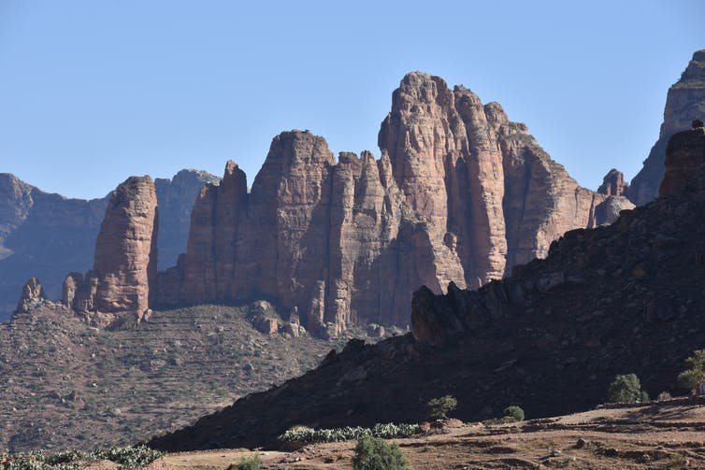
How are rocks different?
Rocks on earth were made billions of years ago from stars in space.

Rocks are found inside the Earth's crust and can reach the surface with volcanoes. When they reach the surface we see them as features like mountains, caves and cliffs. They can break up into smaller rocks like boulders, pebbles and sand.

Rocks can be similar or different in colour, shape, size, texture and appearance depending on how they were made.

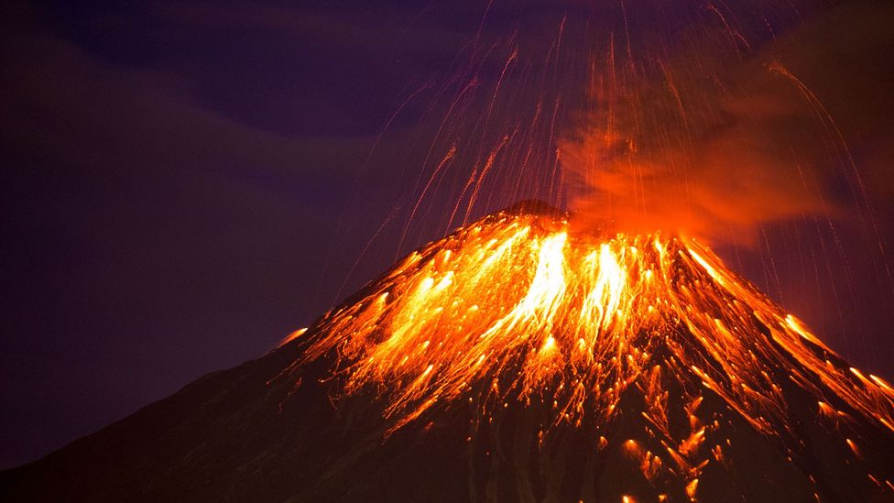

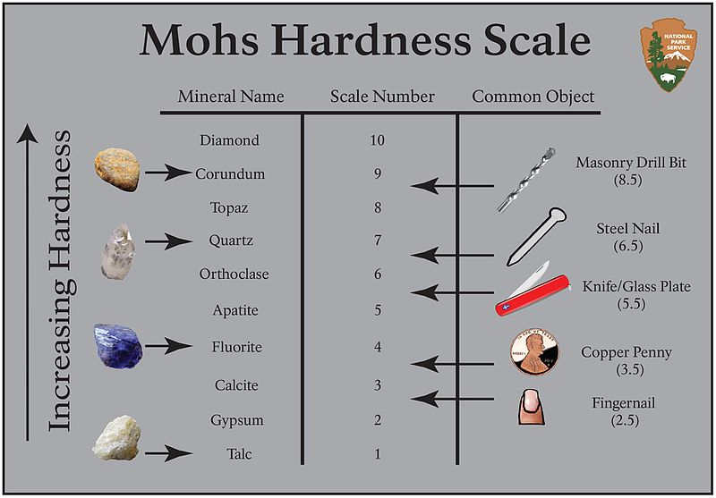
Can rocks be soft?
Rocks can be hard or soft.
The hardness of rocks can be measured on the Mohs Scale.
Hard rocks – granite, precious stones
Soft rocks – talc, chalk, limestone
SUPERFACT: A diamond is the hardest thing on earth

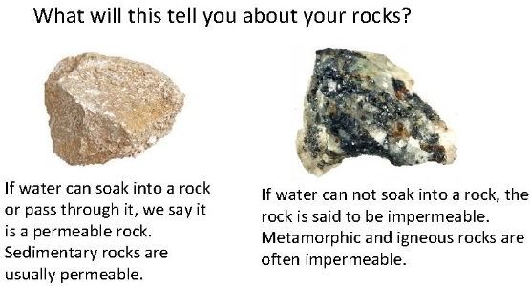
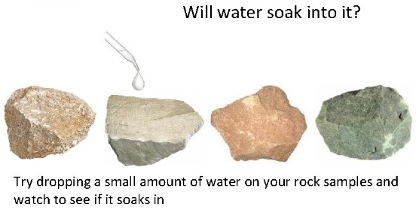
Are rocks permeable or impermeable?
permeable (adjective) a rock that allows liquid or gas to pass through it.
impermeable (adjective) not allowing liquid (e.g. water) to pass through.
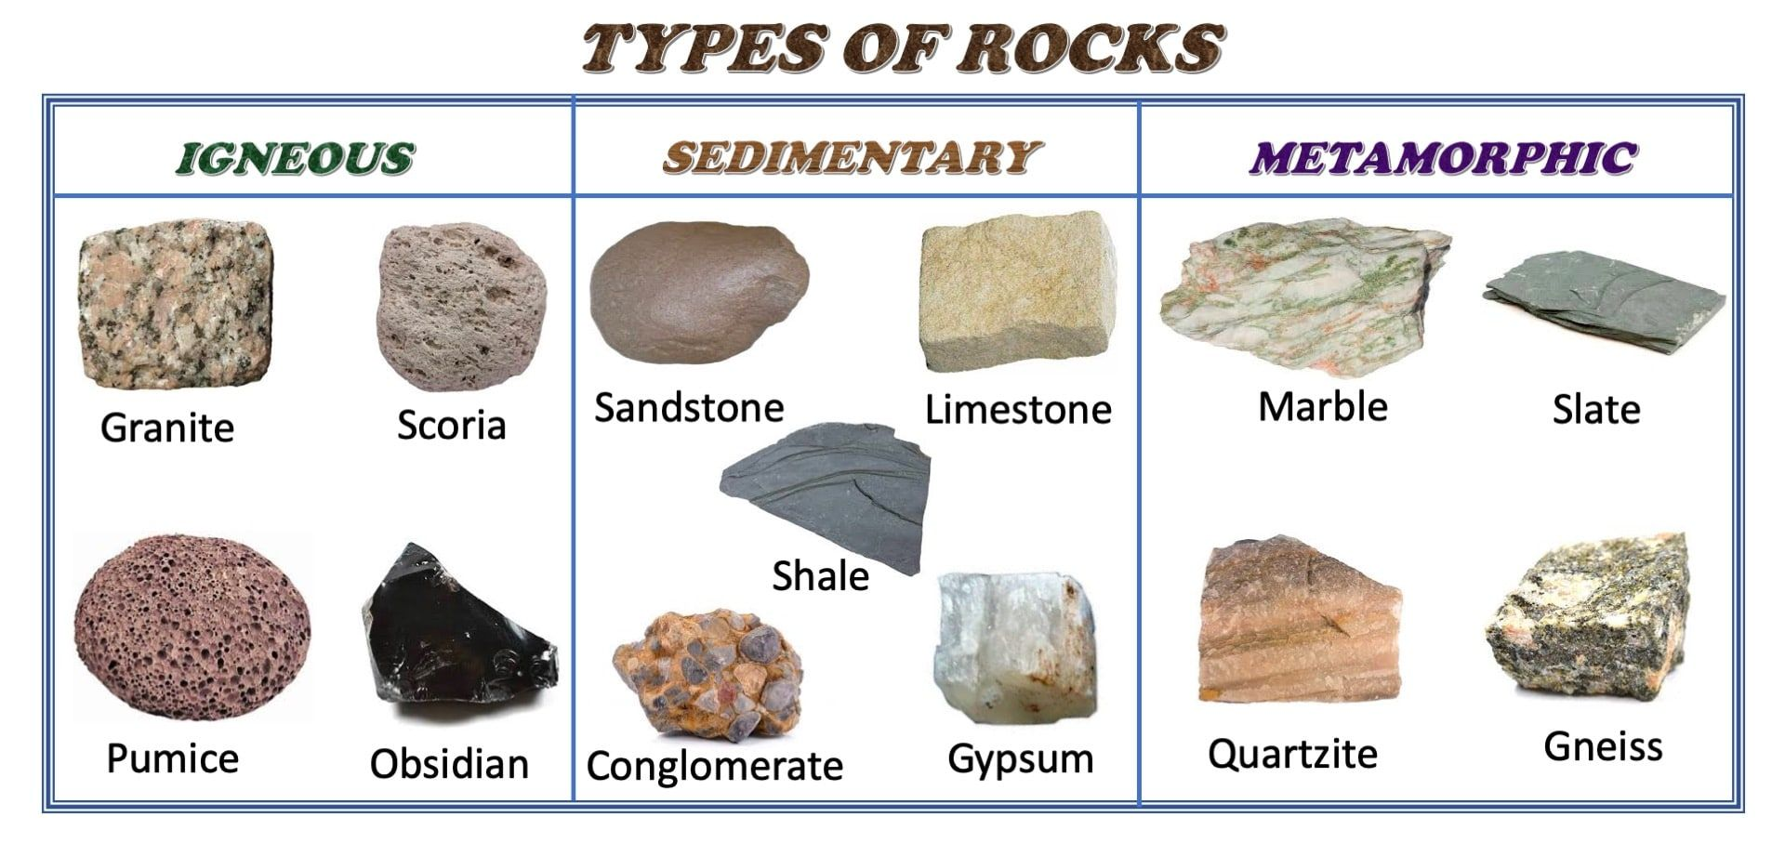
How are rocks made?
Key vocabulary
Spelling | Definition
rock | the solid mineral material forming part of the surface of the earth
permeable | allowing liquids or gases to pass through it
impermeable | not allowing liquid (e.g. water) to pass through
igneous | a rock made from solidified lava or magma
sedimentary | a rock made from layers of sediment deposited by water or air
metamorphic | a rock that has been changed by heat or pressure
magma / lava | hot liquid below (magma) or above (lava) the earth's surface
fossil | the remains of a plant or animal embedded in sedimentary rock

What is a fossil? Fossils are the preserved remains of plants and animals whose bodies were buried in sediments, such as sand and mud, under seas, lakes and rivers.
Igneous rock comes from molten magma. Molten magma is the very hot stuff you find in volcanos! The magma turns to rock when it cools. | Sedimentary rock is very common. It is formed of layers of sand, mud and small stones. The layers are compacted with new layers joining on top. | Metamorphic rocks have been put under a lot of pressure and heat. The pressure and heat can be made by the Earth’s movements. It changes the rocks.
