Dear Parent and Carers,
Year 6 Newsletter
Autumn Term 1

Welcome back to school and welcome to Year 6.
We have quite a few siblings in our class this year, so many of you will already know the ropes but we also have a few who haven’t been with us before…so welcome!
This is going to be a trying year for so many reasons but please be assured that we are here for the children in every possible way.
Here is an overview of what we will be studying this half term:
Subject | Information
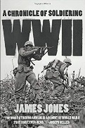  History | Our History topic this half term will be focused on WWII. We specifically look at the blitz and how this affected the country. We also look in to our locality and research where in Salford was bombed and what happened to many Salfordian children.
Science | Our Science for this half term is all about food chains and webs. The children will learn about what eats what and how food chains are affected when one element of the chain is changed. They will study different environments and how these affect food chains.
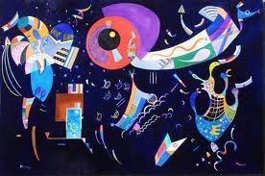  Art | Our Art project will focus on work by Roy Litchenstein. The children have already produced a self-portrait in this style which is displayed outside our classroom. Our resident artist, Mr Hall, will continue to work with the children this year. This half term they will begin to sketch and shade poppies in relation to our WWII study.
PSHE | In PSHE our topic is Being me in my World. The children will be given time to reflect on pertinent aspects of their lives, both in and out of school. They will help each other to work co-operatively in a group as well as making other children feel valued and identify emotions such as happiness and fear.
PE | Mr Foster will take the children for their PE lessons on a Friday afternoon. He will teach the children games skills and has informed me that he has secured some lacrosse training with a qualified coach.
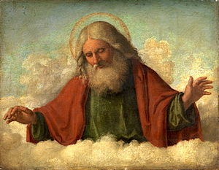  RE | In RE, the children will focus on Christianity and Islam. They will look at the similarities and differences between the two religions and reflect upon their own spirituality and beliefs.  The children will also look at generosity and how we can act generously towards others.
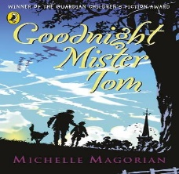  English | In English, we are starting a brand new book – Goodnight Mister Tom by Michelle Magorian. We will generate lots of descriptive writing as well as test our comprehension skills. We will cover lots of different skills too, such as punctuation, spelling, handwriting and using a wide range of sentence styles. Alongside this, the first 20 minutes of each lesson will be  designated to Spelling. In the afternoon, we will spend 20 minutes focusing on Grammar and Punctuation.
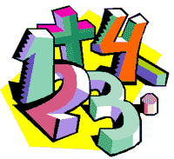  Maths | This term’s Maths’ lessons will be taught through Singapore Maths and deepen the children’s knowledge and capability of Place Value, Addition, Subtraction, long multiplication and long division. Please feel free to visit our school website and view some of the tasks that we have tackled, and how we approach them. The children will also develop their reasoning skills and how to approach more challenging problems as well as developing their arithmetic skills.
Children will be given the following homework:
Subject | Content
Reading | Children should read at home (independently or with an adult) at least 3 times per week. They have been allocated with a reading book and have successfully logged on to, ‘My Book Blog’. Online they can complete related comprehension questions and develop their vocabulary skills. Opportunities to go online will be offered in school to those who do not have access at home.
Spelling | Spellings will be sent home every Monday and will be tested the following Friday. Please help your child to learn their weekly spellings and ensure that they write appropriate and challenging sentences. Children can also access Spellodrome to help them learn their spellings to play word games.
Maths | Times tables will be tested every Friday. Pupils in year 6 are expected to answer 100 times tables within 3 minutes.  The children also have their Times Tables Rock Stars log ins.
Project | This half term, the children are invited to create a project at home. The theme is WWII. They may research any aspect of the war, from battles to artillery or evacuation to spies...the choice is theirs. Please post a photo of the project on to the school spider in the Homework Folder by Wednesday 21st October. We will then look at these photos in class and the children will have the opportunity to talk about what they have learned.
Website | Please have a browse with your child, at all the exciting things on our website. We have lots of blogs and photos about all the goings on in Year 6. Log on to www.wardleyce.co.uk
Please help your child to learn their spellings and times tables as this will ensure that they are working in line with the national expectations. We have found that children who have the opportunity to consolidate their learning, with friends or family, make the most significant progress. Please also ensure your child brings their reading book to school each and every day.
PE is every Friday and the children have been asked to come to school wearing their sports clothes. As most lessons will be outside, please make sure that they are wearing something warm.
If you would like to discuss any concerns, or share something positive, then please contact me at school. Those of you who are there at pick up can speak to me then or if you would a phone call, let the school office know and I will get back to you.

Mrs K Walker
Year 6 Class Teacher/Deputy Head

