God loves and forgives me
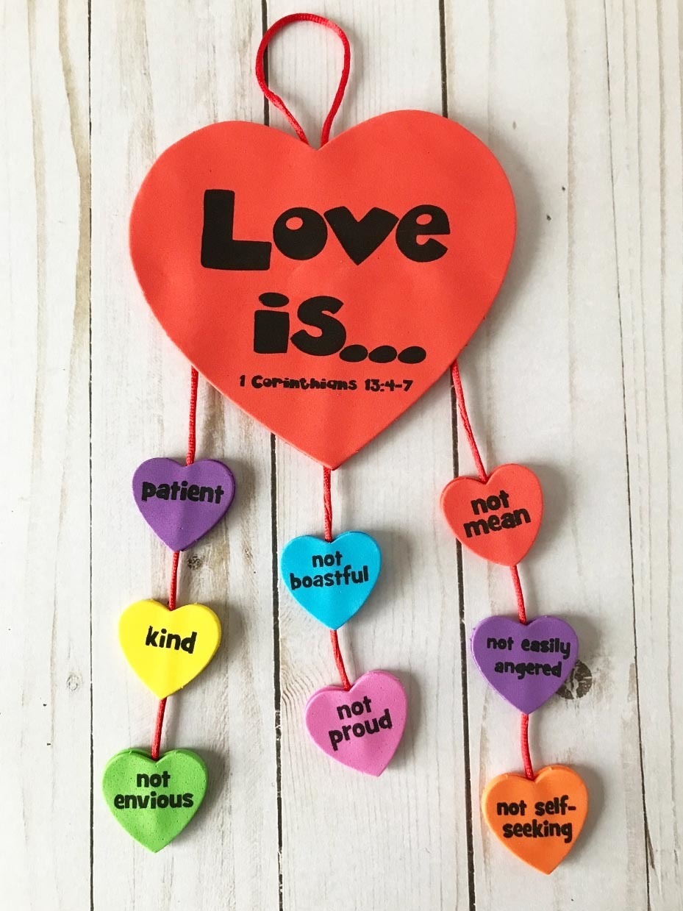
Have a go at making this mobile whilst you think about what qualities God loves in us.

