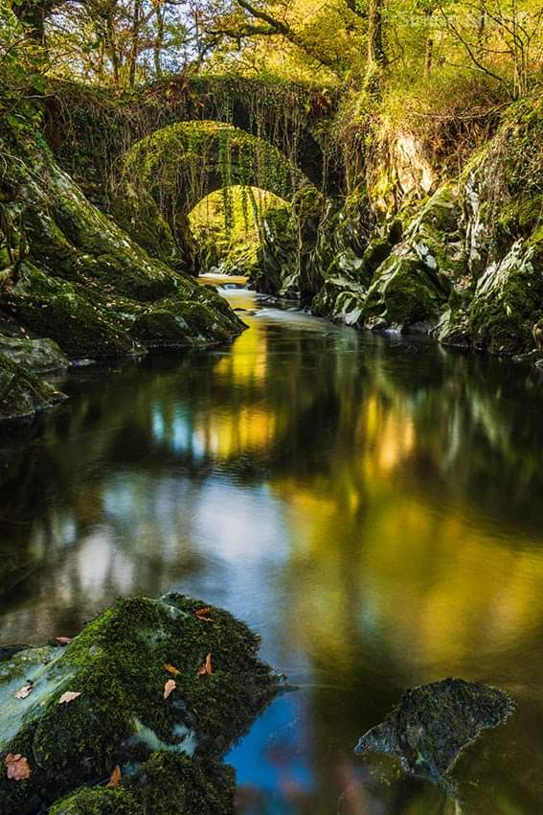
River’s Edge
I breathe in deeply; the silence is bliss. This is just what I needed today.
Perches on the moss-covered rock, I dip my toes in to the cool, calm water. I flinch.
Closing my eyes, I allow my senses to control my experience; I hear the birds, I smell the dew, I feel the damp, moss between my fingers.
Slowly, I open my eyes again and adjust to the fingers of sunlight that shine their rays on to my face. I inhale the warmth. I wonder, how deep is the water? Can I paddle if I roll up my trouser legs or will I soon become waist deep? It is impossible to tell, so I remain seated – better to be safe!
Under the archways, the river continues to flow. I wonder where it goes? May be one day I’ll find out…but not today. Today, I will just enjoy this area.

