 | + | - | x | ÷ | Other
Monday | 19 + + 2 = 27 | 52 – 16 = . | < > or =  4 x 5 2 x 10 | 30 ÷ 5 = | 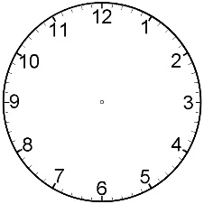
Tuesday | 8 + + 15 = 28 | 31 – 7 = . | < > or =  8 x 2 5 x 3 | 24 ÷ 2 =
Wednesday | 9 + + 12 = 29 | 42 – 12 = . | < > or =  3 x 4 5 x 6 | 18 ÷ 3 =
Thursday | 21 + + 3 = 32 | 63 – 12 = . | < > or =  4 x 10 11 x 3 | 100 ÷ 10 =
Friday | 19 + + 6 = 33 | 55 – 24 = . | < > or =  3 x 7 5 x 5 | 60 ÷ 3 =

