Phonics
Focus for this week: CVC words
Spellings for this week: cup, dog, get, at, pin – practise these words little and often for a test on Friday.
Monday: Recap quickly on the sounds j, v, w, x, y, z, Can children identify the sound quickly? Go through a couple of times. Then, ask your child to read the following words: cup, dog, get, at, pin
Tuesday: Recap on sounds j, v, w, x, y, z, qu. Have a go at writing: cup, dog, get, at, pin
Wednesday: Can you blend to read the Phase 2 words? Click on the link: https://www.ictgames.com/mobilePage/bingo/index.html
Thursday: Recap on sounds j, v, w, x, y, z, qu. Can you blend to read the Phase 2 words? Click on the link: https://www.ictgames.com/mobilePage/bingo/index.html
Friday: Test children on the words for this week (children are to attempt to spell independently): cup, dog, get, at, pin

English
Plan a journey-to go on holiday
Monday - Think about different holidays you have been on. Where have you been? What did you do there? How did you get there? Look at holiday destinations you have been to before on Google Maps/ look at old holiday photographs.
Tuesday -Plan a holiday – Where will you go? How will you get there? Who will you go with? Draw a plan of this?
Wednesday - Pack a suitcase- draw different things you will need in your case for your holiday?
Thursday – Label the items in your suitcase
Friday - Set up a small role play area in the house/ garden to act your journey/ holiday (cardboard box/chairs to make a plane, towels, buckets and spade to make a beach/ den to make a campsite’ etc).

Maths
Monday - Read/watch the story What The Ladybird Heard. (https://www.youtube.com/watch?v=Eu9mPX7DuLA) Look at the picture of the farm below. What can you see? Where is the cow? Where is it going? Where are the cats? Where is the pond? What is on top of the pond?
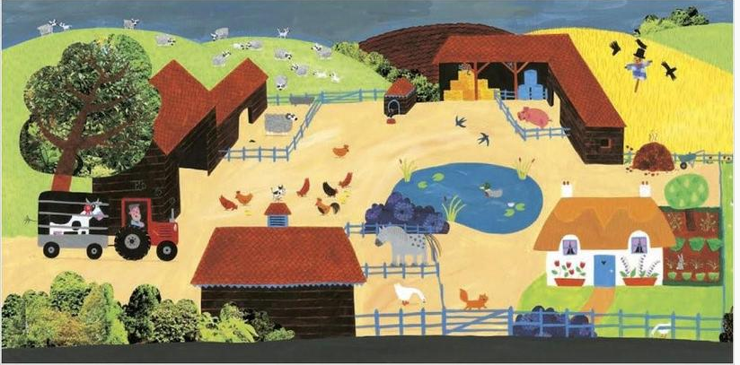
Tuesday – Look at the map in the story of the baddies cunning plan. Make your own map and come up with a plan to steal the cow using positional language. (e.g turn, infront, behind, next to, under, over).
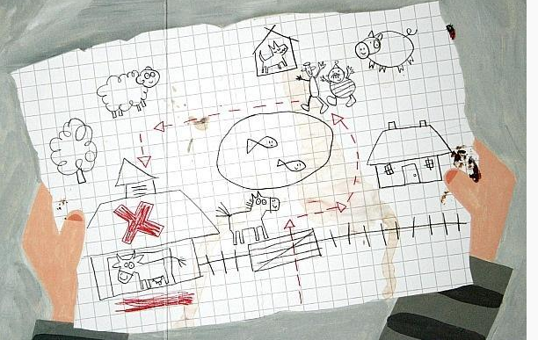

Wednesday – In the story the baddies kept stealing the hens eggs. Place up to 10 mini eggs out in front of you, cover with a cloth and take one away. How many eggs are left? Which egg has been taken. (if you have no eggs any small objects will be fine).

Thursday and Friday - the ladybird in the story has special spots. Think about the arrangement of spots on the faces of a dice. Hide small objects under a cup (e.g stones, smarties) arranged this way. Lift up the cup briefly and place back down again. Get your child to choose the correct picture to represent the objects under the cup. (Encourage children to do this automatically without counting). Your child could then have a go at drawing ladybirds with spots like this.

Creative
Designing and making your own vehicle. You can work at your own pace and decide what to do each day.
Decide on a vehicle you would like to design and make using the materials and resources you have around your house. Have a look at the pictures below to give you some ideas, but there are lots of ideas on the internet.
Draw your design first, could you add some labels?
Over two day, gather your resources and make your model – remember, just use the resources you have around your house.
If you are able to, decorate your model thinking carefully about the colours you would like to use.
Write 2-3 sentences about the vehicle you have made – what vehicle it is, who uses the vehicle, any facts about it.
