Hello Nursery,
I start my maternity leave on Monday, so this is my last post. Attached at the bottom of the page is home learning for the next two weeks.
I have also set up a discussion as usual and Mrs Walker has kindly said that she will check any work uploaded or answer any questions.
It has been a pleasure teaching the children over this last year, they are all little super stars and are a credit to you all.
Thank you all for being so supportive in this difficult time. The emails and phone calls I have had have been so positive and I am so proud to be a part of the Wardley community.
Take care =)
Love and virtual hugs
Mrs Flanagan

Morning =)
Monday
This week’s letter is ‘y’
If you can, eat a yogurt and say ‘y’ before eating every spoon

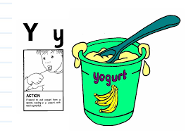
A song to help you learn the sound

https://www.youtube.com/watch?v=futQOvUnHVs

Tuesday – Can you say its sound and action?
Try to find some objects beginning with the sound y.
Play a game of ‘eye-spy’, can you see a word beginning with the letter you are told ie ‘eye spy with my little eye, a word beginning with ………
s (sun), g (grass), b (bike) etc
Once confident can you say the rhyme and ask an adult to guess the word.

Wednesday – Listen to the song about what a plant needs to grow
https://www.youtube.com/watch?v=dUBIQ1fTRzI
Write a list of the things a plant needs to grow. Think carefully about the initial sound in each word. (the word does not have to be the correct letters or spelling – the children just need the confidence to make marks to represent their ideas).
Draw a picture for each word

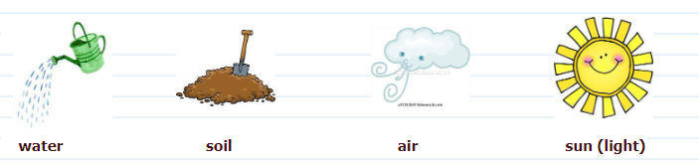
Thursday – Create your own book about ‘How to plant a seed’, try to do some writing and pictures. Try to put the instructions in the order you did when planting your own seed.
Don’t forget to write your name on the cover and give your book a title. Each page can be a mix of pictures and words (again it may just be marks to represent their ideas). Read your book to a teddy and people in your family

Friday – Find different size sticks and practise writing different letters and your name in soil/ sand.

Maths

Monday – Today I want you to do lots of counting
Find lots of different sets of objects you can count ie spoons, teddies, leaves, flowers, cars etc. Touch each one as you count
If you are out and about you could count how many cars/ bikes/ people you see
Do any of the groups have 5?

Tuesday – Last week we learnt all about the number 5. Find 5 flat small objects which are all the same ie buttons, blocks. Can you make different patterns with the 5 objects. Count each time how many you have, the answer should always be 5!

The patterns could include:

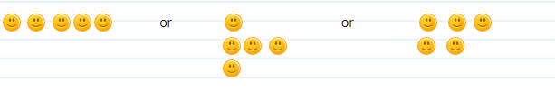

I’m sure you can think of lots more ways to arrange the objects.

Wednesday – Listen to the song all about the properties of 2D shapes
https://www.bbc.co.uk/bitesize/clips/zhnvcdm
Can you say what is special about a circle, triangle, square, and rectangle?
Are you able to draw a picture of a flower using the shapes circle, square and triangle? You may want to add some extra shapes too, do you know their name?
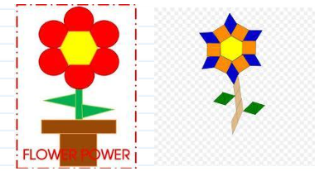
Thursday – Play a game where you have to compare objects and animals by size, using the language biggest, smallest, shortest, longest and tallest
There are 2 games ‘At the Beach’ and ‘Animals’
https://www.topmarks.co.uk/early-years/lets-compare

Friday – Outside on the path use chalk to try and write the numbers 1, 2, 3, 4, 5 in the correct order. Put the correct amount of dots by each number (this can also be done on a piece of paper)

Creative

The Flower Dance, listen to the instructions of Dance-A-Lot Robot and join in his actions
https://www.youtube.com/watch?v=lDoDcHOSUFc

Look around outside what are the different colours of the flowers, can you remember the names for the different parts of a flower?

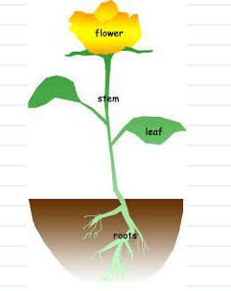

Watch how Sonic Explorer, J, listens to the sounds in the garden and creates a story from the sounds she can make
https://www.bbc.co.uk/teach/bring-the-noise/eyfs-music-sonic-explorers-garden-jungle/zhvmkmn

Explore your garden and see what sounds you can make with the things you find, can you go on an adventure too?

Enjoy =)

