Phonics
Focus this week: The ‘igh’ phoneme.
Spellings for this week: right, flight, might, sigh, what.
- Monday: Recap on sounds ch, sh, th, ng, ay, ee, and igh. Can you think of any words that contain these spellings?
- Tuesday: Watch short Alphblocks clip: https://www.youtube.com/watch?v=CYVcQAZ9gDM Play Roll and Read ‘igh’ sound. See attachment below.
- Wednesday: Practise writing out the following words in your best handwriting: might, bright, sight, right.
- Thursday: Weekly spellings. Play Picnic on Pluto by following the link: https://new.phonicsplay.co.uk/resources/phase/2/picnic-on-pluto Click ‘Start’ then ‘Phase 3’ then ‘+igh’. Can you recognise which are real ‘igh’ words?
- Friday: Spelling test of the above ‘igh’ words. How many did you manage to get right?

English – Mad About Minibeasts

Monday - Follow the link (https://www.youtube.com/watch?v=SW-7MgHEZOE) to listen to the story being read. Can you guess what the different minibeasts are from their description? If you have the book at home, read it with your child.

Tuesday - Draw your favourite minibeast. Write a simple sentence underneath and explain why you like that minibeast the best. Try and use your best handwriting.

Wednesday - Cut out the minibeasts from the sheet attached, or draw your own if you prefer. Can you label each minibeast and write a short description of where these minibeasts can be found. You could make a fact file about them for someone younger.
Thursday - Use the minibeast pictures below and see if you can describe them to a grown up without telling them what the name of the minibeast is – can they guess from your description?
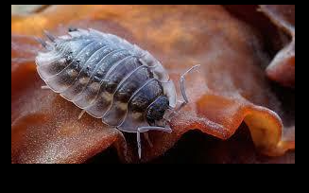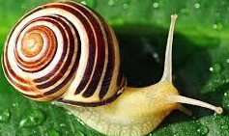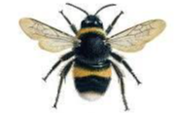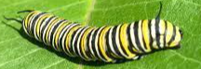

Friday - Create a simple story with your favourite minibeast. This doesn’t have to be written down, the idea is that children use their imagination and can verbally come up with a story, understanding that stories have an opening, a problem and then a resolution. Have fun creating your story!

Maths
Monday - Listen to the story The Princess and The Wizard https://www.youtube.com/watch?v=XyMw-j5Fmnc. What happened to the Princess on each day of the week? Draw pictures to show what happened to her each day.

Tuesday -Play What’s The Spell Mr Wizard. Click on the link for more details https://wrm-13b48.kxcdn.com/wp-content/uploads/2020/06/Day-3-The-Princess-and-the-Wizard.pdf

Wednesday- Make a potion and cast a spell to stop the Wizard coming back and turning everyone to stone. Gather 20 items to put in your potion. Write/ say out loud your spell. See potion/spell examples below.

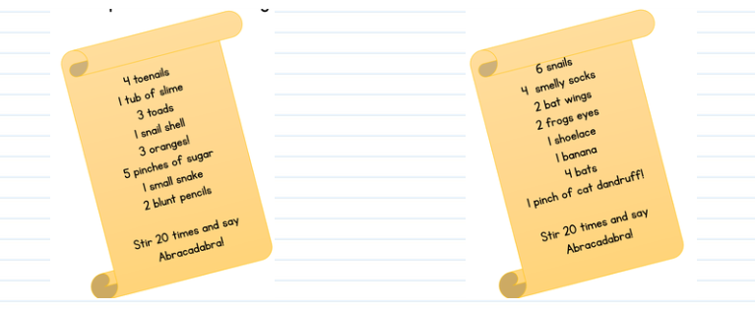

Thursday -Watch the clip about symmetry https://www.bbc.co.uk/bitesize/clips/ztpyr82 Make the Princess’s crown symmetrical (the same on both sides) See link for more details https://wrm-13b48.kxcdn.com/wp-content/uploads/2020/06/Day-5-The-Princess-and-the-Wizard.pdf. Use a small mirror to help you.

Friday – Mathletics challenges

Here is another task around the theme seaside, enjoy =)
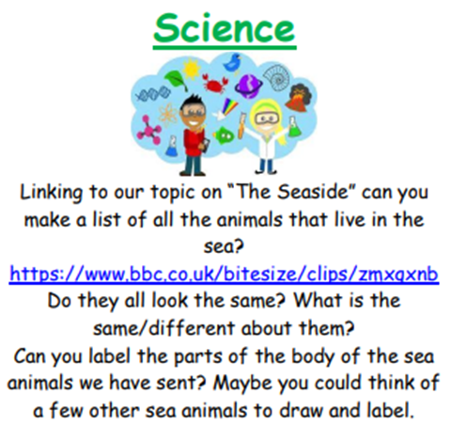

A little extra creative task if you fancy =)
Design your own healthy minibeast snack (see photo’s below). What minibeast would you make? What fruit/vegetables/equipment would you need to make it?

