Usain Bolt
Look at this fantastic piece of art work by Charis Tsevis. I love how the colours have been used to express his speed.
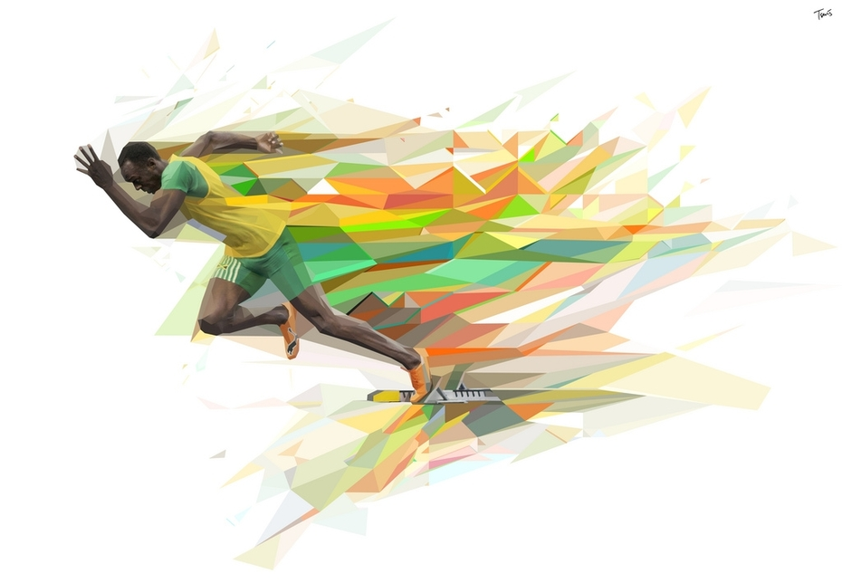
Have a go at generating your own Usain Bolt piece of art using this style.

