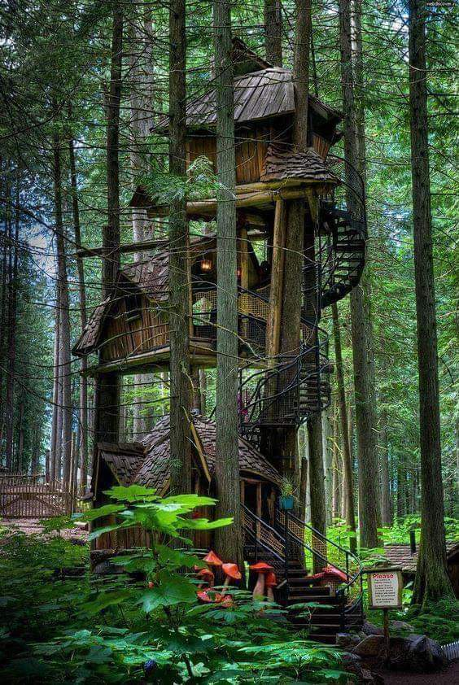
Tree House Adventure
Imagine that have stumbled across this tree house whilst adventuring in the woods with a friend. What would you do?
Write a short story based on your adventure:
Ist paragraph: describe the setting
2nd paragraph: add action – find the tree house and explore, what did you do, what did you see, who could you meet?
3rd paragraph: How will you extract end? Did you leave the tree house and return home or does something happen to prevent you from leaving?
________________________________________________________________
__________________________________________________________________________________
__________________________________________________________________________________
__________________________________________________________________________________
________________________________________________________________
__________________________________________________________________________________
__________________________________________________________________________________
__________________________________________________________________________________
________________________________________________________________
__________________________________________________________________________________
__________________________________________________________________________________
_________________________________________________________________________________
________________________________________________________________
__________________________________________________________________________________
__________________________________________________________________________________
__________________________________________________________________________________
________________________________________________________________
__________________________________________________________________________________
__________________________________________________________________________________
__________________________________________________________________________________
________________________________________________________________
__________________________________________________________________________________
__________________________________________________________________________________
__________________________________________________________________________________
________________________________________________________________
__________________________________________________________________________________
__________________________________________________________________________________
__________________________________________________________________________________
________________________________________________________________
__________________________________________________________________________________
__________________________________________________________________________________
__________________________________________________________________________________
________________________________________________________________
__________________________________________________________________________________
__________________________________________________________________________________
__________________________________________________________________________________
________________________________________________________________
__________________________________________________________________________________
__________________________________________________________________________________
__________________________________________________________________________________
________________________________________________________________
__________________________________________________________________________________
__________________________________________________________________________________

