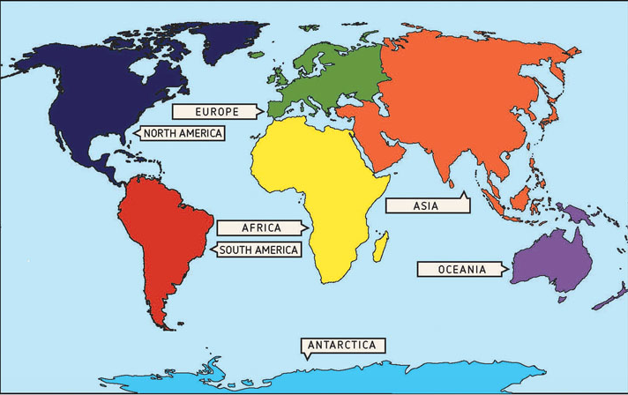

Find out one of the continents Try to find your chosen continent on a globe. Where it is in relation to where you live? How far away is it? If you wanted to go there, how would you travel?
Create your own fact file about your chosen continent, including things like how big it is, which countries are in the continent, what is the weather like, which animals live there, are there any mountains, deserts, waterways etc.? You can design it any way you like, the more creative the better.

