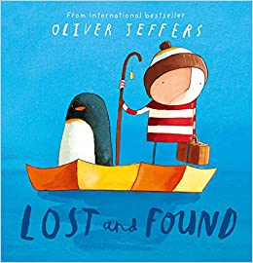

The little lost penguin travels from the South Pole, in the continent of Antarctica, to meet the Boy. Create an alternative story using different characters and continents e.g. a baby panda arrives on a boy’s doorstep and he has to take him back to Asia, a koala bear arrives on a girl’s doorstep and she has to take her back to Oceania. Of course you can think of your own characters, animals and continents. Think about their journey, how they would get there, will it be similar to the journey in the story? Will the ending be the same?

