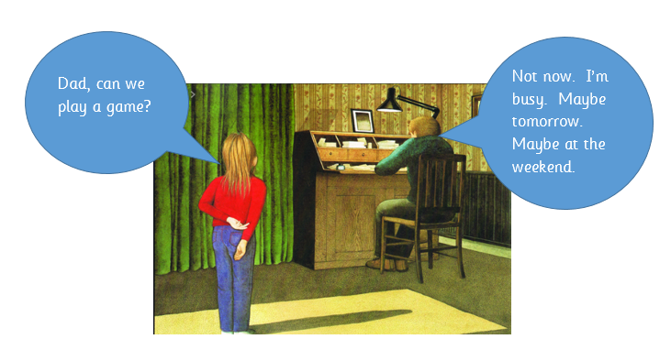
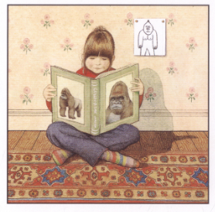

Hannah’s dad was always too busy.
Hannah read books about Gorillas.

‘Gorilla’ Storyboard
Anthony Browne is a wonderful storyteller but he is also a remarkable artist. The pictures in this book are amazing, extremely beautiful and could actually tell the story all by themselves. So, I thought it would be nice if we could do something to include them.
Draw a storyboard/comic strip of the story, using speech bubbles and descriptions. I have done an example of the first two pictures for you above. I have actually flipped the second picture around so it is easier to show who is speaking first and added some extra speech for Hannah. You can do the same in your storyboard. You can copy my ideas above, but then you can obviously draw your own pictures for the rest of the story.

