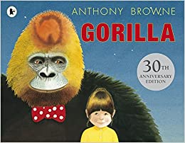

Read/listen to the story of ‘Gorilla’ by Anthony Browne. There are lots of links to the book on YouTube but I particularly like this version, read by a little girl in Key Stage 1 - https://youtu.be/DsZn210fGWo
Write a similar story, but based on a different animal?
You can entitle your story Our Enchanted Night Out or (Type of Animal) e.g. Giraffe, Zebra, Tiger.

