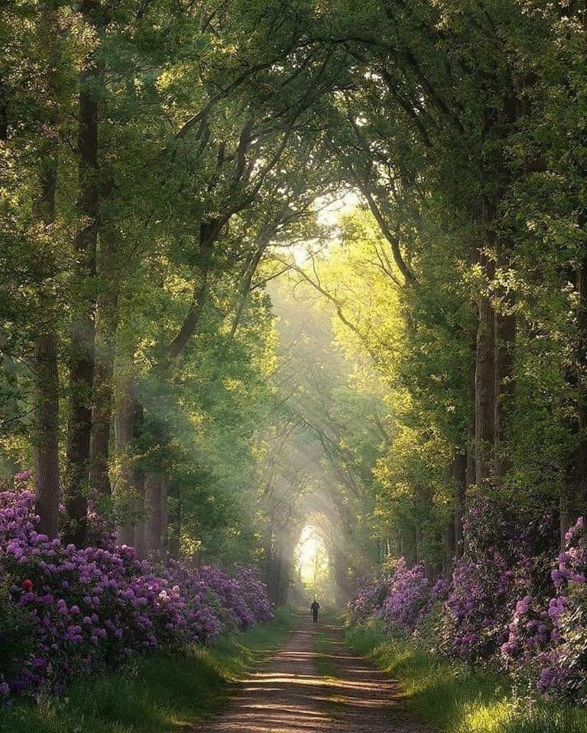
Summer Days – Descriptive Poem

Fingers of light slither through the interludes caused by the contours of the leaves.
Purple hydrangeas form a protective barrier along the pathway; they are the guards to the meadow that lies ahead.
Tall, thin Sycamores reach across at their tips – finding each other as they tenderly sway in the warm, summer breeze.
The pathway, which guides any passenger safely through to the clearing, elongates the walk-way.
A singular figure strolls serenely towards the arched light-way at the end; does he know what spectacular vision lies ahead?
As he approaches the clearing, he gently inhales the scented air and absorbs the beauty that lies ahead.
Now have a go at writing your own poem.
Remember to include personification, metaphors etc. and most importantly, think very carefully about your language choices; they need to generate a beautiful image in the reader’s mind.






















