Writing Task
The Story of Medusa
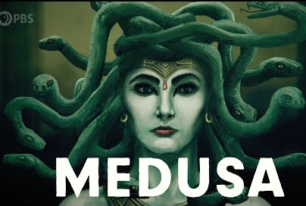

Read the story of how Medusa gained her snakes… I would like you to re-tell the story in your own words.
You could write a comic strip, write a play script, write a narrative or even write a newspaper article about it – the choice is yours!
You can add pictures too – have a go at drawing your own Medusa

