Tasks for this week =)

Phonics
- Focus this week: CVCC/CCVC words with Phase 3 phonemes.
- Spellings to practise this week: toast, paint, spark, creep, said.
Monday: Follow the link for an introduction to this week’s phonics. https://www.youtube.com/watch?v=hId3S5uzdLQ
Tuesday: Recap on the phonemes igh, ow, ar, oi, oa, ear and this week’s spellings. Create anagrams of the following words – sport, green, chain. Write the letters of the words on paper and cut out the sounds before jumbling them up. Can the children put them back in the correct order?
Wednesday: Recap on the phonemes igh, ow, ar, oi, oa, ear and this week’s spellings. Try the Word and Picture match attached.
Thursday: Recap on the phonemes igh, ow, ar, oi, oa, ear and this week’s spellings. Follow the link below to play Help a Hedgehog. Enter your own words: sport, burnt, sleep, float, boost, punch, frown, queen. https://www.ictgames.com/mobilePage/helpAHedgehog/
Friday: Spelling test of this week’s words. How did you do? They were tricky this week, so don’t worry if you didn’t do as well. We will continue looking at words like these.

Picture match
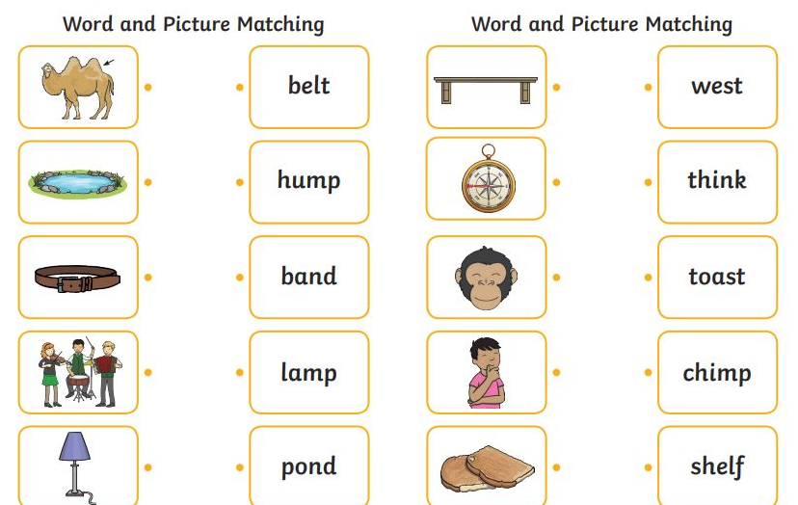

English –Caterpillar Shoes
- For a warm up each day, have a go at matching the lowercase and uppercase letters by spending 5 minutes on: http://www.literactive.com/Download/live.asp?swf=story_files/mouse_house_US.swf
This gives the letter names instead of the letter sounds, which children need to learn too, being able to match the letter name with the sound it makes. Different letters are given each time you play.
Monday: Watch the video Caterpillar Shoes (https://www.youtube.com/watch?v=tYa6OLQHrEc) and pause at different parts to talk about it. For example, when the spider is dangling – do they know what this means? Can they think of another word that means similar to ‘dangling’? Why doesn’t caterpillar stop and give some of his shoes to the stick insects? Talk about the word ‘camouflage’ and what this means. How do the stick insects feel? How do you know? Can the children retell the story of what happens in the video from memory?
Tuesday: Listen to the video again. Can the children pick out any words that rhyme? You may need to give the children one of the words and then replay the section with the rhyming word in. See if you can collect some rhyming pairs and write them down.
Wednesday: Come up with a sentence together about Caterpillar Shoes (e.g. Caterpillar grows too big for his shoes and gives them away.) Write this sentence for your child quite big on paper and cut the words out, spreading them out. Can children remember the sentence and re-arrange the words into the correct order?
Then do this for the main parts of the story. Can your child re-arrange the main parts back together with no support?
Thursday & Friday: For the last two days, spend the time writing the story of Caterpillar Shoes. Break it down to write 2-3 sentences each day. E.g. Caterpillar grew too big for his shoes so he gave them away. First he gave some to woodlouse. Then, he gave some to spider and grasshopper and snail. He gave his last shoe to some fleas. Next he turned into a beautiful butterfly. If your child will find it hard to write so many sentences, condense the story and just write 2-3 sentences.

Maths
Monday: Watch the story of The Snail and The Whale https://www.bbc.co.uk/iplayer/episode/m000cslw/the-snail-and-the-whale. Make your own snail shells using the recipe below. Can you solve some subtraction problems using your snail shells. E.g you have 16 and you eat 3. How many are left? You have 11 snail shells and you eat 2. How many are left? You have 7 snail shells and your eat 6. How many are left?

Tuesday: Solve the addition problems on the link https://wrm-13b48.kxcdn.com/wp-content/uploads/2020/05/Day-2-The-Snail-and-the-Whale.pdf . Use language first then and next when solving the problems. E.g First there are 2 snails…then 2 more come along….now there are 4 snails.

Wednesday: Watch the clip about odd and even numbers https://www.bbc.co.uk/bitesize/topics/zknsgk7/articles/zt4jj6f . Work out if the snail has an odd/even number of friends in the photos below. Use counters to help work out the answers.

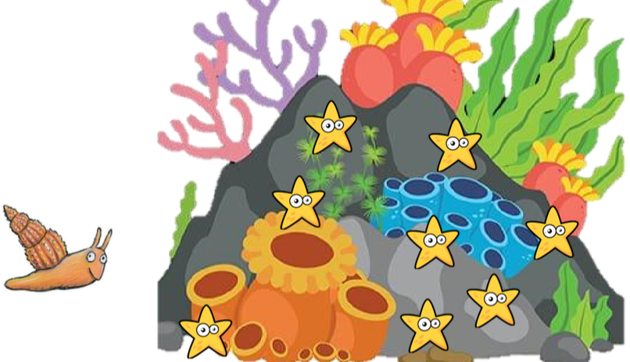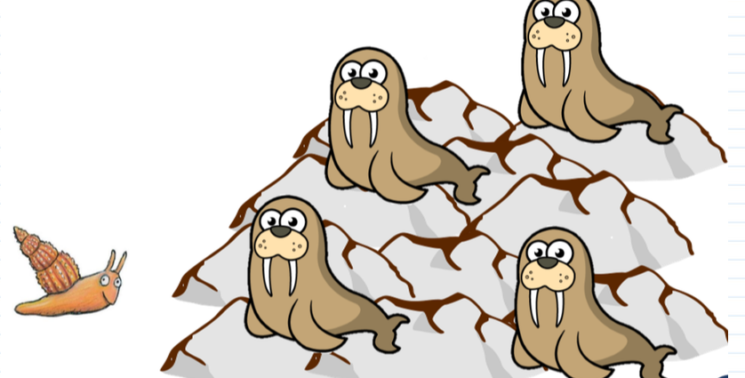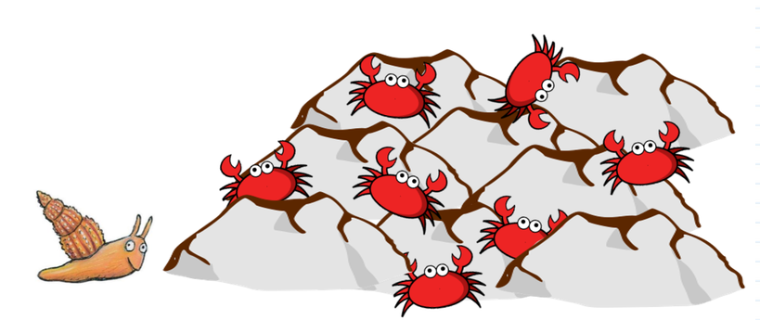

Thursday: Complete the odds and evens ladybird worksheet attached.

Friday: Draw your own odd/even animal story and get someone to answer it.

Creative (Geography)
This week, I would like you to look at tourist attractions in Blackpool. Have a look at the ‘Blackpool’ PowerPoint at the bottom of the page. From this, create a poster featuring all the ‘fun’ things to do in Blackpool! Remember you are trying to entice potential tourists to come and visit.

You might also find some useful information at:
https://www.visitblackpool.com/plan-your-trip/tourist-information-centre/

As an extra challenge, try and make your poster as bright and colourful as possible!

Mrs Flanagan

