Kandinsky Art work

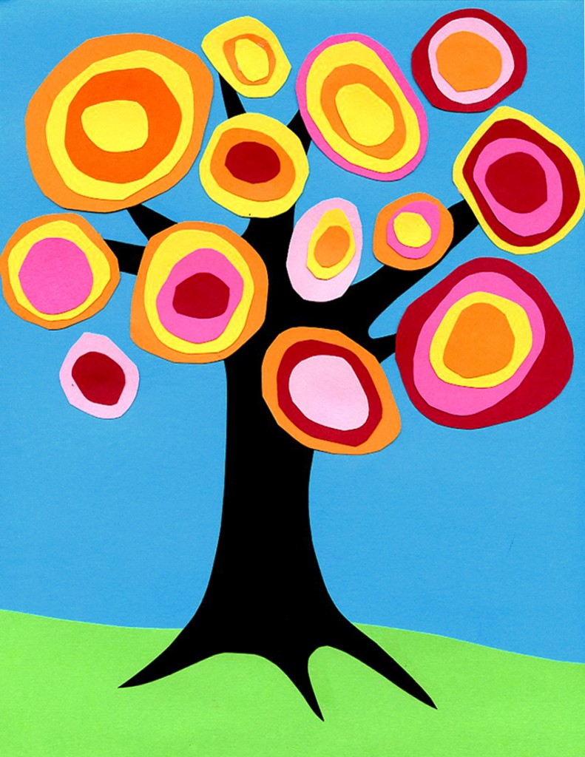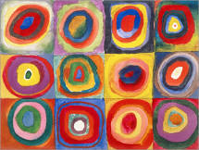

This week, I would like you to generate your own, ‘Kandinsky Tree’.

You can use any art material – as you can see, the one in the picture has been made from coloured paper, but you can use coloured pens or pencils if you want to.

I look forward to seeing your beautiful art work ☺

Squares with Concentric **Circles** (Farbstudie - Quadrate und konzentrische Ringe), is perhaps, **Kandinsky's** most recognizable work, is not actually a full-fledged picture. This drawing is a small study on how different colour combinations are perceived that the painter used in his creative process as a support material.