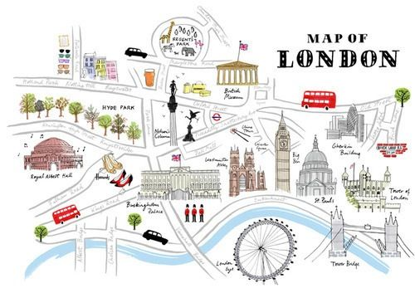

History of a London Landmark

- Research the history of one of the different landmarks that Katie and Jack see on their trip to London.
- Present your information imaginatively.
You can create a fact file, use photographs or do your own drawings.
I know you will have some amazing ideas and I cannot wait to see them.
- Use this link https://www.projectbritain.com/london/ to find out about some of the historical sites in London or do your own research. Don’t forget if you are using the internet make sure you have an adult’s permission or get an adult to help you.

