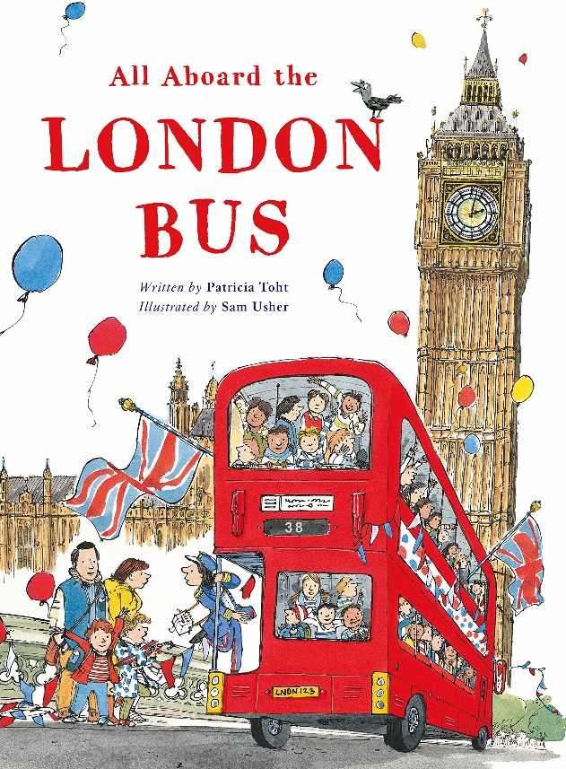

Write a Seek and Find Poem
- Read the poem Trafalgar Square from the poetry book “All Aboard the London Bus”. You can find a copy of it attached to this week’s Blog.
- Look at how the poem has been written.
10 pigeons scatter as toddlers run and play.
9 ladies chatter on their way to a café.
8 performers pose as grateful tourists clap.
- Have a go at writing your own Seek and Find poem.
You can use one of the other London landmarks that Katie visits or you could write about a place that you know really well e.g. the Trafford Centre, a local park, somewhere you have visited for the day or on holiday.
- If you struggle to come up with a 10 line poem you can always write a shorter one. Start with 1 and work your way backwards.
- Have a look at my attempt about one of my favourite places ‘Scarborough’.
I began with 1 lighthouse, red and white, standing tall.
Then I came up with my other lines.
When I copied it out I started with my biggest number first.

Scarborough
5 amusement arcades where we spend all our money.
4 fish and chip shops that sell delicious, hot vinegary chips.
3 statues where we always take happy, smiling pictures.
2 orange life boats bobbing up and down on the sea.
1 lighthouse, red and white, standing tall.

