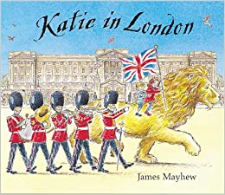

Write a diary based on Katie in London

1. Katie, Jack and the Lion visited lots of different places in London like Trafalgar Square and Harrods.
Make a list of all the famous London landmarks that they visit, in the correct order.
2. Write a diary entry from Katie's point of view about her trip to London.
- Remember you are pretending to be Katie so make sure you use ‘I’ and not Katie when writing.
- You can start of in the present tense in your first paragraph
- Move to the past tense for the rest of your diary.
- Try and use a new paragraph for each different landmark.
- Don’t forget to use adjectives to describe things.
- Use verbs and adverbs.
3. You can use this paragraph to begin your story or come up with one of your own.
It is late afternoon, as I sit on a bench in Trafalgar Square with Jack and my Gran and I think about our exciting day in London. I fondly gaze up at the majestic lion, with a Harrod’s knitted blanket under his tummy, and I remember some of the amazing adventures that we have had today.
It was early morning when Jack, Gran and I happily caught the number 9 red bus that took us through the busy streets of London to Trafalgar Square…..

.

