Hello =)

English and Phonics

Monday – Watch the videos below about different minibeasts

https://www.bbc.co.uk/bitesize/topics/z6882hv/articles/z9fkwmn
https://www.bbc.co.uk/cbeebies/games/mini-beast-adventure-with-jess-minibeast-spotter

Write down a list of all the minibeasts you have just seen and maybe draw a picture of then too.
Listen carefully to the sound at the beginning of each word, can you identify the initial letter, ie w for worm, s for snail…………………., and then try to write it.
(it does not have to be the correct letters or spelling – the children just need the confidence to make marks to represent their ideas)
Can you think of any more minibeasts to add to your list?

Tuesday – Listen to the story ‘What the Ladybird Heard’ by Julia Donaldson
https://www.youtube.com/watch?v=Eu9mPX7DuLA

Discuss all the things the ladybird heard. Can you pretend you are a ladybird and travel around your house and garden and describe all the different noises you can hear?

Wednesday – Today you are going to be a Letter Detective, how many of these letters can you find around the house? Can you find them more than once?

If you would like to be a ‘Super’ Letter Detective try to find all the letters we have learnt this year in Nursery.

s, a, t, p, i, n, g, o, c, k, m, d, e, x, h, f, v, u, r, b, w, qu, z

Thursday - Make a pattern like a shell of a snail. In the air begin to draw anti-clockwise circle, keep going round and round and getting bigger and bigger

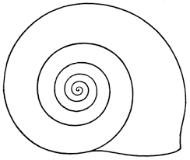
Now see if you can do the same with paint or chalk.
Friday - I would like you to FaceTime someone in your family and tell them all about the story ‘What the ladybird heard.’
Don’t forget to use your expression boys and girls =)

Maths

Monday - Make your own worms to measure, using string or cooked spaghetti cut into different lengths, start with 3 worms.
Can you find the shortest? Longest? Can you put the worms in order of size?
Now add more worms, let your worms go for a wriggle and repeat the activity.

Tuesday – Look at the different ladybird pictures and count how many spots does each ladybird have?
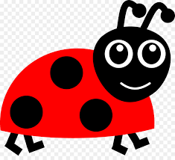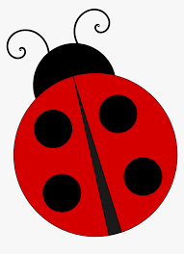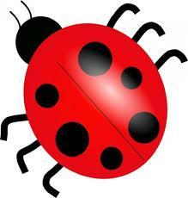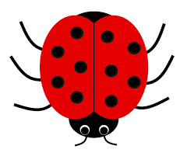

Wednesday - Draw your own ladybirds and put on 1 spot, 2 spots, 3spots, 4 spots, …………..10 spots

Thursday – Play the shape monsters game, post the shape into the correct monsters mouth. (At Pre-School we have learnt that rectangles are also referred to as oblongs)

https://www.topmarks.co.uk/early-years/shape-monsters

Friday – Make a number line 0-10. Now with that number line find out one more of each of these numbers: 0 2 5 6 8 10

Creative tasks

Can you create your own dance as you sing along to the Ladybird song
https://www.youtube.com/watch?v=rY5ajMMFO28
Try to create a song about another minibeast

Make a collage of your favourite minibeast using any old material, wool, paper etc. Make it as colourful as you can

Go on a Minibeast Hunt.
Look carefully to see how many you can find, remember to walk quietly and slowly so you don’t scare them away. They sometimes like to hide underneath things too!
Try to write down or draw a picture of all the different minibeasts you see.

