The Problem We All Live With by Norman Rochwell

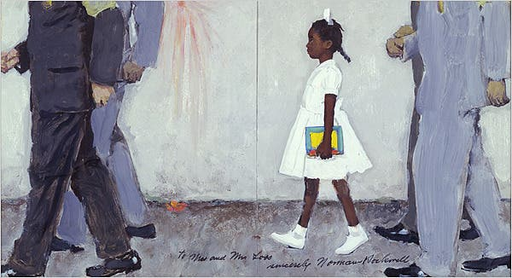

Generate your own piece of artwork to represent this historic moment.

