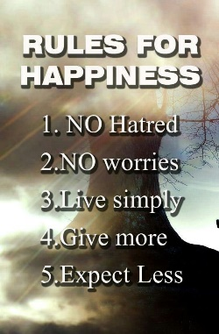
Making a Rule Card
Do rules matter? Why? What is a code for living?
- Choose a ‘villain’ from stories, films or TV series that you love. What makes these people bad? What rules do they break? What does their breaking of a code for living lead to?
- Example: In Disney’s ‘The Lion King’ Scar, the villain, is selfish, ambitious, and a liar. These things lead him to deceive his nephew, murder his brother and steal the kingdom.

- Make lists of 10 things they think are naughty. What are the effects or consequences of these naughty things?
- Are there such things as naughty thoughts? Think about jealousy, hatred, being greedy and so on start in our minds, and sometimes lead to actions as well. Films again provide a reference point: the thought is often the beginning of the deed. Cruella De Vil thinking greedily about a coat made of puppy fur in 101 Dalmatians leads to the action of stealing the puppies.

- A person often has a ‘code for living’ inside their head or heart that helps them to choose good things and say no to bad things.

- We make rules or principles to help us to be good. What rules or principles do you think make most people happy? What really matters in life for yourself – is it honesty, fairness, freedom, truth, peace?

Task
- Suggest one rule for people to follow if they want a happier world.
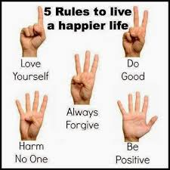
Make a beautifully lettered ‘rule card’ and decorate it.

