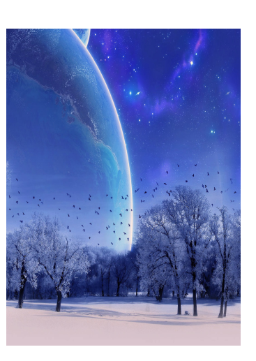
Space Adventure – Narrative

Imagine you are a space explorer and
you have landed upon a new planet!

Write a story about what happens when
you leave the comfort of your spaceship
to explore the unknown planet.

Think about:
Who your companions are
What you see
What you encounter
What you learn from your adventures

Story Opening…
Opening the high-glossed doors to our spaceship, my entire body was enveloped with excitement; what lay ahead of me? Taking a deep breath, I stepped cautiously on to the ground below, on to the unknown land. My fellow adventurers behind me, we ventured in to the new world - on planet Oberon. Trees danced in the warm breeze while insects fluttered in to the azure sky...simply stunning! I could not believe my eyes as a satisfied smile developed across my face. Was I really here? Had I really be chosen for this amazing mission?
Reality gripped me as my companion, Jason, nudged me forward - he wanted to explore. Turning to glimpse the excitement in his eyes, I gave him a knowing glance as we stepped in to the unknown...

Space Adventure – Narrative

__________________________________________________________________________
_______________________________________________________
_______________________________________________________
________________________________________________________
__________________________________________________________________________________
__________________________________________________________________________________
__________________________________________________________________________________
__________________________________________________________________________________
__________________________________________________________________________________
__________________________________________________________________________________
__________________________________________________________________________________
__________________________________________________________________________________
__________________________________________________________________________________
__________________________________________________________________________________
__________________________________________________________________________________
__________________________________________________________________________________
__________________________________________________________________________________
__________________________________________________________________________________
__________________________________________________________________________________
__________________________________________________________________________________
__________________________________________________________________________________
__________________________________________________________________________________
__________________________________________________________________________________
__________________________________________________________________________________
__________________________________________________________________________________
__________________________________________________________________________________

