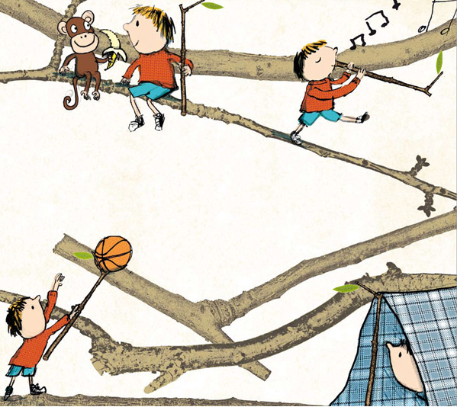

Stanley’s Stick

Stanley stands on Stockport station with his stick.
Stanley always carries his stick with him.
Stanley’s stick was once part of something tall and grand and it will never return.
But it can still be a stick as best as it can.
Stanley has a lot of stick activity.
Like pretending the stick is a whistle or a banana that is quite straight.
You don't have to be great to be great.
Like pretending the stick is a match to catch the world aflame.
There is game after sticky game.
Look it's a dinosaur that isn't extinct.
It’s a Stickosaurus.

Stanley has tried out some names for his stick.
Like starry and moon.
But those names were all the wrong shape.
For a while he liked Stirry.
But that is better for a spoon.
Stanley stick is very good for writing in the sand in languages only Stanley can understand.
And four times now he has used it to pick up slugs from pathway platform and pavement, thus saving them from a fate worse than feet.

Stanley's friend Bertie has some string and sometimes they tie the string to the
stick’s end and go pretend fishing.
“Because the fish are pretend, no fish get hurt,” says Bertie.

So here is Stanley standing on the station, taking his stick for a short stay
at the side of the sea with his mum and dad.
The train pulls in.
Down at the sea Stanley goes down to the side of the tide.
His folks take stock of Stanley standing in the sand, stick in hand.
What is he doing?
Maybe the boy thinks it is time for the stick to be taken for someone else to enjoy?
Stanley hurls his stick into the wide tide.
Gosh.
What a tiny splosh for something that has been so big in Stanley's days.
The sea picks up the stick and tucks it into itself.
Stanley is stickless.
The next morning, back at their spot on the beach, the tide is out.
Stanley treads towards the spreading sea.
Boats ride seaback out on the distance.
Stanley decides to look for interesting sticks.
For other sticks which have been carried twiggy-back upon the turning tide.
Soon he stumbles upon a stick alone upon the shore.
It is quite different from the stick he had before.
The stick is an unusual saxophone.
Stanley thinks of home and begins to blurt a tune for Bertie.
Now Stanley stares through his stick telescope at the sea.
It is wonky.
And this stick, Stanley know the name of.
It is called… Fantastick.
Stanley’s Fantastick.

by John Hegley
