Andy Goldsworthy
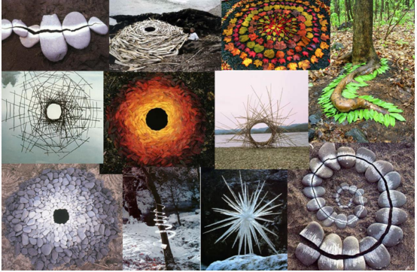

Andy Goldsworthy is a British sculptor, photographer, and environmentalist who uses nature to create ‘transient’ artwork. He photographs his artwork and sculptures because they are ‘transient’, which means they are temporary pieces of work. He leaves them in the environment and lets them be blown by the wind, melt, float on the water, be naturally transferred or simply fade away. To see some more of Andy Goldsworthy’s work have a look at the sheet I have uploaded ‘Andy Goldsworthy Project’.
Now it is your turn
Use items around your house to create your own Andy Goldsworthy inspired piece of art!
- If you can do this outside; try using items found in nature to create your piece of art! If not, you can use fun items around the house to create your own masterpiece.
- Take a photo.
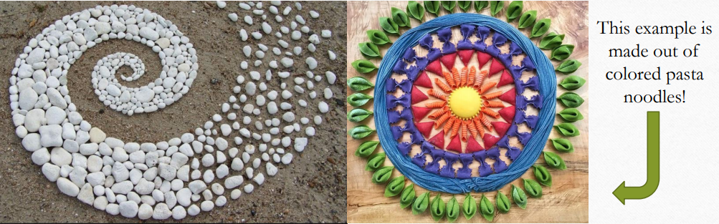
- Have fun and be creative!

