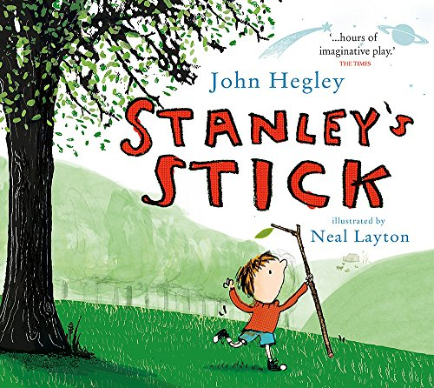

Write your own poem based on Stanley’s Stick

- Stanley pretended his stick was lots of different things like a dinosaur or a plane.
Make a list of 10 things you could ‘make believe’ with a cardboard box e.g. a boat, a fort etc.
- Using alliteration – where words begin with the same letter, like Stanley’s Stick, come up with your own character name, for your poem, beginning with B. e.g. Bertie’s Box. (You can use Bertie if you like or come up with a name of your own).
- Using your list of ideas, write your own poem based on Stanley’s Stick
See if you can put some more alliteration in there too.

Here is the beginning of the poem to help you get started

Stanley stands on Stockport station with his stick.
Stanley always carries his stick with him.

You could begin a similar way:

Bertie bounces around Bramhall station with his box.
Bertie always carries his box with him.

or you could come up with your own idea for the beginning of your poem.

