Phonics
This week in phonics I want you to watch some RWI Phonics lessons at home.
To help children learning to read at home during school closure, they are streaming 7 phonics, reading and spelling lessons every weekday on their YouTube channel.
Link: https://www.ruthmiskin.com/en/find-out-more/parents/
Each lesson is ten to fifteen minutes long and available for 24 hours.

Literacy
Monday 8th - Talk about a time you have visited a farm and the animals you saw there or listen to a story about Topsy and Tim visiting a farm
https://www.youtube.com/watch?v=xftLYUow1z0

Tuesday 9th – Using some of the animals we see at the farm, can you think of any words which rhyme with their name (don’t worry if your child says a nonsense word) ie pig, dig, jig, mig (nonsense word)

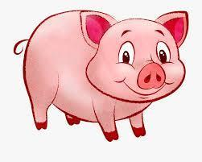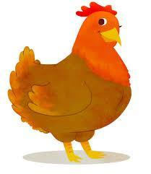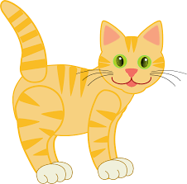

Ask an adult (or you could try too) to write the rhyming words underneath each other, can you recognise a pattern with the rhyming words? Can you say the letters of a new rhyming word?

Wednesday 10th – Set up a reading area, maybe in your favourite place outside or inside, can you think of an unusual place to create it? Make it cosy with blankets and cushions. Take any animal books or Nursery Rhyme books and maybe some teddies/ dolls and read/ sing stories and rhymes using the pictures. Which is their favourite story/ rhyme?

Thursday 11th – Write an interesting fact about a farm and draw a picture.
(Again, it does not have to be the correct letters or spelling – the children just need the confidence to make marks to represent their ideas)

Friday 12th – Dough Disco
https://www.youtube.com/results?search_query=dough+disco+for+children

Maths
Monday 8th – Go on a Shape Hunt inside and outside
How many squares can you see?
How many circles can you see?
How many triangles can you see?
How many rectangles can you see?

Which shape has the most? least?

Tuesday 9th - Make a collection of animal toys of similar size. Talk about how some of the animals can be the same and how some animals are different. Sort them into sets ie. number of legs, colour. Can you think of another way to sort the objects?

Wednesday 13th – Find 4 flat small objects which are all the same ie buttons, blocks. Can you make different patterns with the 4 objects? Count each time how many you have, the answer should always be 4!

The patterns could include:

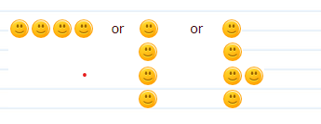

I’m sure you can think of lots more ways to arrange the objects.

Thursday 14th – Outside on the path use chalk to try and write the numbers 0-10 in the correct order, can you know do 0-20? Put the correct amount of dots by each number (this could also be done on a piece of paper with crayons)

Friday 15th – (Related to Fri Topic)
Using your obstacle course you have created can you describe how to move through it, using the words first, under, over, through, next, finally.
Maybe tell your teddy what to do or give instructions for someone else to follow.

Creative
Monday 8th - Sing-a-long to the song ‘Old McDonald had a Farm’ and listen carefully to the sounds each farm animal makes, as you sing-a-long
https://www.youtube.com/watch?v=_6HzoUcx3eo

Are there any extra farm animals you can add to the song? Can you sing it all by yourself?

Tuesday 9th - Look at and discuss the special characteristics of each farm animal
i.e. a pig is pink and has a curly tail, a hen has feathers and 2 legs

Paint or collage a picture of some of the animals you see on a farm. Remember to choose the correct colours

Wednesday 10th – Can you move and dance like the different farm animals, below are dances you can follow

CBeebies: Boogie Beebies - Barnyard Boogie
https://www.youtube.com/watch?v=hMEZz3CJJ6c
Or
CBeebies Let’s Go
https://www.bbc.co.uk/cbeebies/watch/lets-go-club-funky-chicken

Can you create your own Farmyard dance?

Thursday 11th - Using any construction type toys you have at home can you build your own farmyard
It could have fields, barns, haystacks, farm house, and fences to keep the animals in their field. Choose one of your toys to be a farmer and add any farm animal toys you may have, maybe add a tractor too!

Friday 12th - Make an obstacle course in the garden
Try to find something you can balance on, travel through, go around, go under

