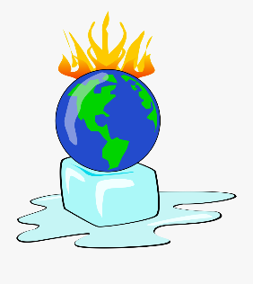
Climate Change

Read through the Power Point Presentation and watch the videos that are attached.

This research task asks you to consider the effects of climate change in relation to your local area. Depending on where you live, there may be obvious examples to consider, e.g. flooding. According to climate scientists, extreme weather is more likely to happen more often in the future due to climate change. You should consider the impact of heat waves, storms and flooding on your way of life and local area.

I have also attached the teacher notes so that you can read through to get some ideas of what tasks to complete as there are many within the pack. The obvious one would be to produce a poster or an information text about what climate change is.

You could also complete some of the craft ideas that are explained within the pack.

