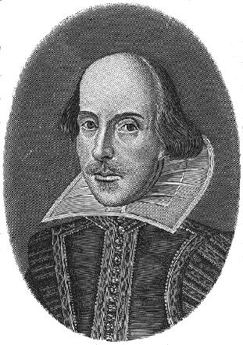
William Shakespeare
Read the information sheet about William Shakespeare and then in your own words, write an information text about him. You can use questions as sub-headings if you like but you do not have to. If you’re able to, feel free to do some more research about him to help assist your writing.
Watch a short clip about him on BBC Teach – just log in to YouTube and type William Shakespeare BBC Teach and it will come up.




