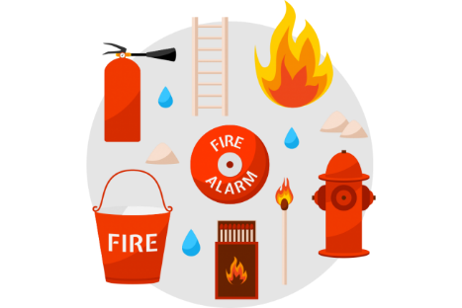

**The Importance of Fire Drills**

Using the information in the comprehension task, create a poster that displays the importance of fire drills.

Remember, a poster should be bold and eye-catching. It should include key words that are important to the reader and images that best represent the message you are trying to get across.

