Skittles Colour Experiment
You will need:
- plate – one with a rim is better if you have it
- bag of skittles
- jug of warm water (from the tap, not the kettle, but you still may need an adult to help).
- a square of paper about the size of the middle of the plate
- kitchen roll
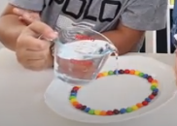
1. Arrange the skittles around the plate (inside the plate rim) in a repeating pattern

2. When you have made a circle of skittles gently pour some warm water into the middle of the circle. You need to put just enough so it fills the middle of the plate, touching the skittles, but not too much so it goes over the top and floods the skittles.
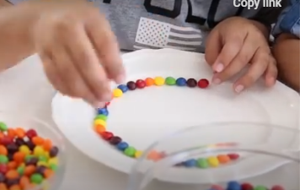

3. Make a prediction about what will happen. Which means have a guess.
4. Then simply wait and watch what happens. Were you correct?
5. Make sure you take a picture of your result
6. If you want to, see if you can take a print of the result using your square piece of paper. This sometimes works, but doesn’t always. Dip the paper in the middle of the plate, turn it over onto kitchen paper and allow it to dry. You might need adult help here.
7. Try and work out why this happens.

