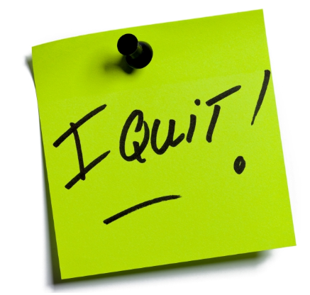

Write a new story about everyday objects that decide to quit e.g. “The day the toys quit”, “The day the books quit” or “The day the utensils quit”. You can use one of these titles or make up one of your own.
- use correct punctuation
- use adjectives
- use neat handwriting

