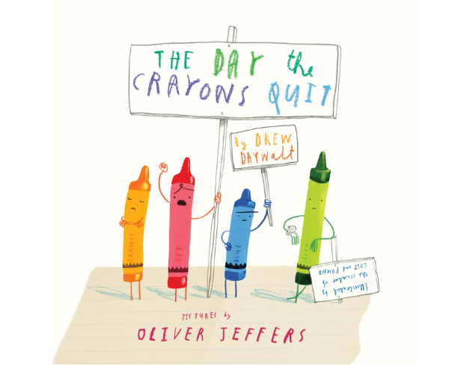

Pretend you are Duncan and write a reply to one of the crayons' letters.
- set it out like a proper letter
- use correct punctuation
- keep your writing neat

