Welcome back Nursery =)
Phonics
Each week we will look back at the letter sounds we have previously learnt. Try to find some objects beginning with the sounds. Can you play eye-spy?
This week's letters: n, g, c, k. Please could you practise your formation on any bits of scrap paper you may find around the house.

Fred talk these words;
n - n-i-p n-o-t n-e-ck
g - g-a-p g-o-t g-e-t
c - c-o-t c-a-t c-o-g
k - k-i-t k-i-d k-e-y

As a little extension can you write these words and can you think of anymore?

English
Monday 1st June – Listen to the story of Tiddler by Julia Donaldson
https://www.youtube.com/watch?v=qcTQADUywZY&t=66s
Discuss the story together and try to include the questions:
Where is the story taking place?
Who is in the story?
What does Tiddler do in the story

Tuesday 2nd June - Can you write the name for each of these animals which live in the sea

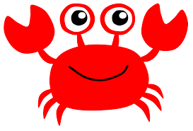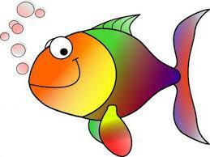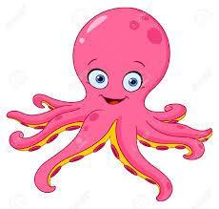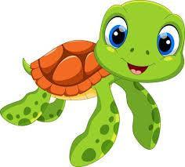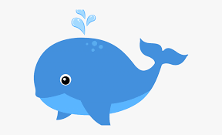

Listen carefully to the sound at the beginning of each word, can you identify the initial letter, f for fish, w for whale…………………., and then try to write it.
(it does not have to be the correct letters or spelling – the children just need the confidence to make marks to represent their ideas)

Can you draw a picture of them too?

Wednesday and Thursday - Create your own book about an animal which lives in the ocean, try to do some writing and pictures. Don’t forget to write your name on the cover and think of a good name to call your book (again it may just be marks to represent their ideas). Read your book to a teddy and people in your family.

Fri 5th – Can you think of anything else that lives in the sea? Draw a picture and label what you can think of. I asked my niece this question the other day and she came up with a seahorse!

Maths

Monday 1st June
Can you spot all the differences in Andy’s Aquatic ‘spot the difference’ quizzes?

https://www.bbc.co.uk/cbeebies/puzzles/andys-aquatic-adventures-spot-the-difference
https://www.bbc.co.uk/cbeebies/puzzles/andys-aquatic-spot-the-difference

Tuesday 2nd June
Find 2 objects which are the same but different heights or lengths ie bottles, teddies, sticks. Put them next to each other and decide which is
the smallest/ shortest to tallest/ longest
Repeat for 3 or 4 objects

Wednesday 3rd June
Look again at the story of Tiddler by Julia Donaldson

https://www.youtube.com/watch?v=qcTQADUywZY&t=66s

Can you count how many fish are on each page? (don't worry if there are too many fish to count on some pages)
Which page has the most fish?
Are there any pages which have only 1 fish on? 2 fish on? 3 fish on?

Thursday 4th June
Make a simple ribbon wand
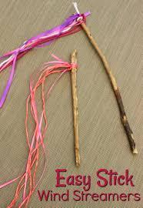

Use your wand to draw different shapes in the air, can someone in your family guess the shape you are drawing? Try to write numbers 0- 10 with your wand.

Friday 5th June
Try to complete Andy’s Aquatic jigsaw
https://www.bbc.co.uk/cbeebies/puzzles/andys-aquatic-adventures-jigsaw-game

Creative

Monday 1st June
Use the music ‘Under the Sea’ from the ‘Little Mermaid’ film
Create a dance, you could be Ariel the mermaid or Sebastian the crab and and perform it to your family
https://www.youtube.com/watch?v=GC_mV1IpjWA

Tuesday 2nd June
Make a ‘pretend’ ocean
You could use a see-through plastic box, bowl, jar, bucket or sink
Use your imagination about what could go inside ie, sand, stones, shells, blue food colouring
If you have any plastic sea creatures they could go in to.

This activity will continue tomorrow.

Wednesday 3rd June
Use a plastic character which will fit inside your ‘pretend’ ocean, let them go on an adventure and tell the story. They could be a diver or mermaid, maybe they find some treasure or make a friend with a sea creature.

Thursday 4th & Friday 5th June
Join Andy and sing along to his raps about some ocean creatures ‘Cool crabs’, ‘fish fiesta’, ‘funky octopus’

https://www.bbc.co.uk/cbeebies/watch/andys-aquatic-raps-playlist#playlist

Enjoy this weeks tasks everyone, I will open a discussion for you to post anything you might want me to see. =)

Mrs Flanagan

