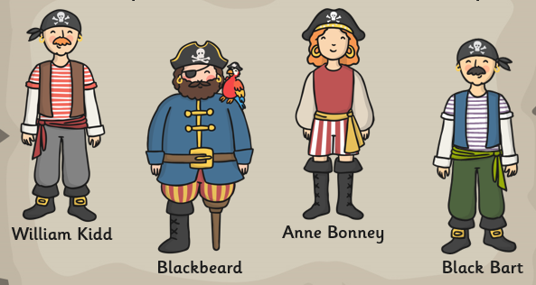

Famous Pirates
Find out about the history of one of these famous pirates. Write a fact file about their lives including things like when they were born, where they came from, the names of their ships and any other interesting facts that you can find.

