Tribal Adventure

Write an adventure story based on the image below. Think about what has happened, who is involved and what might happen next…

Below are some sentence ideas to get you going:

Before them lay a ship; a ship that was suspended in the air! How had it got there?

The grass danced gracefully around the chief's feet.

Shining splendidly, the sun's rays penetrated the dark leaves that sheltered the tribe's village.

Like stars...the dew on the green grass shimmered under the slither of light.

Crack! The leaves crunched under his feet.

Despite the dangers that lay ahead, the warrior knew that he had no choice: he had to investigate.

In front of him lay adventure; behind him was safety of his tribe...which pathway
​would they choose?

A finger of light fought its way through the gnarled branches of the dark undergrowth within the rain forest.

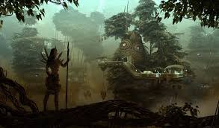
Tribal Adventure

______________________________________________________________________________________________________________________________________________________________________________________________________________________________________________________________________________________________________________________________________________________________________________________________________________________________________________________________________________________________________________________________________________________________________________________________________________________________________________________________________________________________________________________________________________________________________________________________________________________________________________________________________________________________________________________________________

