Sheet A | + | - | Quarter | x | Other
Monday | 13 + + 12 = 38 | 83 – 26 = . | Quarter of 16 | 4 x 3 = | 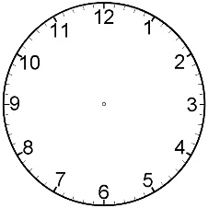
Tuesday | 18 + + 12 = 45 | 61 – 9 = . | Quarter of 8 | 7 x 3 =
Wednesday | 14 + + 16 = 51 | 90 – 14 = . | Quarter of 20 | 9 x 3 =
Thursday | 17 + + 13 = 62 | 72 – 68 = . | Quarter of 12 | 6 x 3 =
Friday | 19 + + 11 = 73 | 100 – 36 = . | Quarter of 4 | 5 x 3 =
Sheet B |  | - | Quarter | Partitioning | Other
Monday | 66 + 25 = | 43 – 26 = | Quarter of 16 | 45
Tuesday | 19 + 24 = | 21 – 9 = | Quarter of 8 | 45
Wednesday | 27 + 35 = | 30 – 14 = | Quarter of 20 | 45
Thursday | 79 + 14 = | 72 – 68 = | Quarter of 12 | 45
Friday | 28 + 28 = | 45 – 36 = | Quarter of 4 | 45
Sheet C | - | Doubles | Halves | Shapes | Coins
Monday | 63 - 2 = | Double 5 | Half of 6 |  | 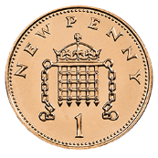
Tuesday | 49 + 7 = | Double 3 | Half of 14 |  | 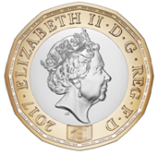
Wednesday | 38 - 1 = | Double 7 | Half of 20 |  | 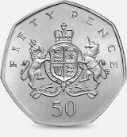
Thursday | 26 - 2 = | Double 4 | Half of 10 |  | 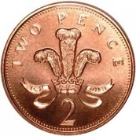
Friday | 79 - 8 = | Double 9 | Half of 4 |  | 