|  |  |
| --- | --- |
| See the source imageworm |  |
| See the source imageant |  |
| See the source imagebutterfly |  |
| See the source imagecaterpillar |  |

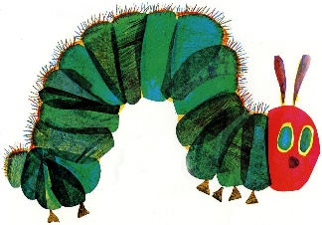

**Minibeast Hunt**

|  |  |
| --- | --- |
| See the source imagewoodlouse |  |
| See the source imagemillipede |  |
| See the source imageladybird |  |
| See the source imagespider |  |