Sheet A | + | - | Halves | x | Other
Monday | 13 + + 2 = 20 | 43 – 26 = . | Half of 6 | 5 + 5 + 5  x = | 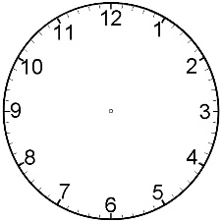
Tuesday | 8 + + 10 = 20 | 21 – 9 = . | Half of 14 | 10 + 10 + 10 + 10 + 10  x =
Wednesday | 4 + + 12 = 20 | 30 – 14 = . | Half of 20 | 5 + 5 + 10 + 10  x =
Thursday | 16 + + 3 = 20 | 72 – 68 = . | Half of 10 | 2 + 2 + 2 + 2 + 2 + 2  x =
Friday | 19 + + 1 = 20 | 45 – 36 = . | Half of 4 | 5 + 10 + 5 + 10  x =
Sheet B |  | - | Halves | Partitioning | Other
Monday | 64 + 25 = . | 43 – 26 = . | Half of 6 | 36
Tuesday | 19 + 24 = . | 21 – 9 = . | Half of 14 | 36
Wednesday | 27 + 35 = . | 30 – 14 = . | Half of 20 | 36
Thursday | 79 + 14 = . | 72 – 68 = . | Half of 10 | 36
Friday | 28 + 28 = . | 45 – 36 = . | Half of 4 | 36
Sheet C | + | Doubles | Halves | Shapes | Coins
Monday | 63 + 2 = | Double 5 | Half of 6 |  | 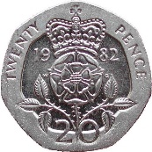
Tuesday | 41 + 7 = | Double 3 | Half of 14 |  | 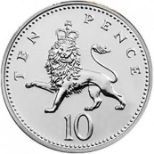
Wednesday | 38 + 1 = | Double 7 | Half of 20 |  | 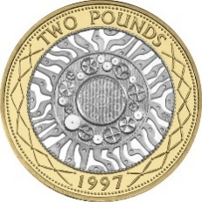
Thursday | 26 + 2 = | Double 4 | Half of 10 |  | 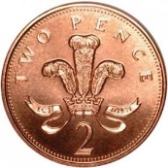
Friday | 72 + 8 = | Double 9 | Half of 4 |  | 