Sheet A | + | - | Is it in the 5 times tables? yes or no | ÷ | Other
Monday | 15 + + 4 = 20 | 43 – 26 = . | 471 | 25 ÷ 5 = | 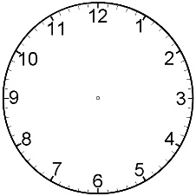
Tuesday | 6 + + 10 = 20 | 21 – 9 = . | 635 | 18 ÷ 2 =
Wednesday | 3 + + 12 = 20 | 30 – 14 = . | 840 | 12 ÷ 3 =
Thursday | 8 + + 3 = 20 | 72 – 68 = . | 366 | 50 ÷ 10 =
Friday | 14 + + 3 = 20 | 45 – 36 = . | 975 | 60 ÷ 5 =
Sheet B | Column addition | Column subtraction | x | ÷ | Other
Monday | 53 + 28 | 50 - 12 | < > or =  6 x 5 25 | 35 ÷ 5 =
Tuesday | 19 + 15 | 42 - 17 | < > or =  10 x 4 50 | 16 ÷ 2 =
Wednesday | 37 + 25 | 38 - 19 | < > or =  3 x 2 4 | 18 ÷ 3 =
Thursday | 16 + 46 | 74 - 56 | < > or =  2 x 9 20 | 90 ÷ 10 =
Friday | 34 + 29 | 60 - 39 | < > or =  5 x 5 10 | 55 ÷ 5 =
Sheet C | + | Counting in 2s, 5s and 10s | Number bonds | ÷ | Coins
Monday | 63 + 2 = | 0, 2, 4, 6,___, 10 | 10 | 3 x 5 = | 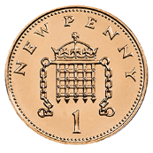
Tuesday | 41 + 7 = | 0, 5, 10, 15, ____ | 10 | 10 x 2 = | 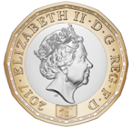
Wednesday | 38 + 1 = | 0, 10, 20, ___, 40 | 10 | 12 x 5 = | 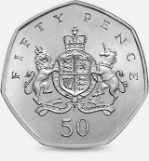
Thursday | 26 + 2 = | 0, 2, 4, 6, 8, 10, _____ | 10 | 6 x 10 = | 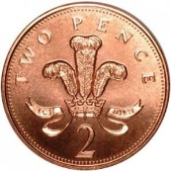
Friday | 72 + 8 = | 10, 20, 30, 40, 50, ________ | 10 | 8 x 10 = | 