Top tips for reading with your child
Level 1 | Simple questions involving what is on that page, eg, ‘What is this?’ or ‘Who is this?’
Level 2 | Questions involving a little more thought about what is on that page, eg, ‘Where is…?’ or ‘How many…?’
Level 3 | Questions that require a little more thought about the story as a whole or the characters, eg, describing what is happening, describing the characters or making simple predictions.
Leve 4 | Questions that require your child to justify their response, eg, ‘Why?’ questions. Ensure that their reasoning is fairly reasonable and not completely random.

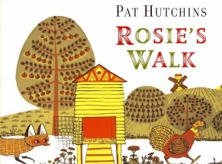
The following are examples of questions requiring different levels of understanding.
They are based on ‘Rosie’s Walk’, a great story that involves lots of positional language.

Level 1 | - ‘What is this?’ whilst pointing to a fox.  - ‘Who is this’ whilst pointing to Rosie.
Level 2 | - ‘Where is the fox hiding’?  - ‘How many windows are on the house?’
Level 3 | - ‘What might happen next?’  - Whilst pointing to the hen and the fox, ‘How are these the same? How are they different?’
Leve 4 | - Whilst pointing to the hen house, ‘Why is this called a hen house?’  - Why can’t Rosie see the fox?

Finally, if you log on to the following website, the scheme that we follow in school to teach early reading (Read Write Inc) has made lots of its resources free and readily available for parents to use at home to support home learning. These include the sound booklets and handwriting worksheets that the children would have been using if we were still in school.
It really is a super resource to be available free of charge and I would definitely get my hands on some of them if I were you.
https://home.oxfordowl.co.uk/reading/reading-schemes-oxford-levels/read-write-inc-phonics-guide/

