Jesus’ body is placed in a tomb

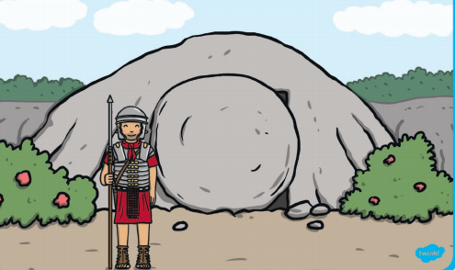

Jesus’ friends find the tomb empty

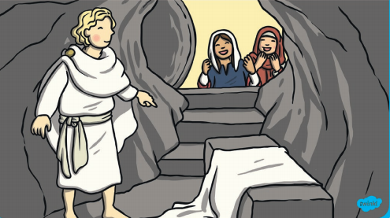

Jesus ascends to Heaven

