Year 5 | + | - | ÷ | X
Monday | 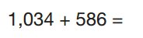 | 472 − 9 = | What is the square root of 144? | Is 121 a square number? Explain. | An angle less than  ______is called an acute angle.
Tuesday | 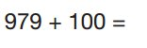 | 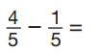 | 1416 ÷ 7 | 378 x 6 | An angle more than _________but less than  ______is called an obtuse angle.
Wednesday | 19, 956 + 100 | 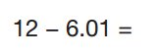 | 9917 ÷ 9 | 56 x 34 | An angle more that ______ is called an reflex angle.
Thursday | 29, 987 + 100 | 4, 589 - ______ = 4, 509 | 53 ÷ ____ = 0.053 | ______ x 364.2 = 36420 | An angle of _______ is called a right angle.
Friday | 38, 986 + 100 | 10, 000 - 1 | 678 ÷ _____ = 0.678 | 578 x ______ = 57800 | 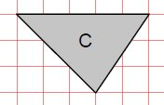  How many acute angles does this shape have?
Mistakes are brilliant – they help us to learn

