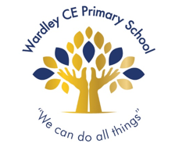
Reception newsletter, Spring term 1

Dear parents and carers,

Here you will find useful information about what we will be doing over the next few weeks in Reception:
Physical development | We have our PE sessions on Thursdays.  Your child should come into school wearing their PE kits (black PE shorts or jogging bottoms, plain white t-shirt, black pumps or trainers, jumper or jacket).
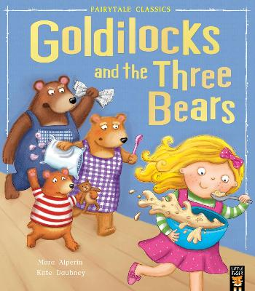  Literacy | As well as daily story time sessions, we will have a core story over the next half term: Goldilocks and the Three Bears.  We will use this book to learn about story structures, characters and settings, as well as to be a focus for writing opportunities. Your child will continue learning how to write in sentences, concentrating on spelling words how they sound and developing their ability to form and remember their own sentences.
Maths | In maths, we will continue learning about number bonds. Help at home by encouraging your child to recall number bonds to 10 independently. For example,  I need 20 strawberries. I have 3, how many more do I need?
Understanding the World | We will be learning all about People Who Help Us over the next few weeks. Within this topic, children will talk about people in the community they have come across that help us (police officers, firefighters, nurses etc) and find out about what their role entails.  Are you, or anyone you know, in a role that the children would be familiar with, such as the emergency services, and would be happy to talk to the class about the things you do? If so, please get in touch and we can arrange a visit to school.
Expressive Arts and Design | As part of our topic about People Who Help Us, children will be taking part in some junk modelling where they will be creating their own emergency service vehicle using cardboard boxes.  In order to support this activity, please send your child into school with a few boxes/ tubes/ bottles/ egg boxes. Please note, due to hygiene reasons we cannot accept toilet roll tubes.

Important things to remember:

Home reading | Home reading books will be changed Tuesday and Friday. Please make sure your child’s reading book bag, reading book and reading diary are in school everyday both days.
Labelling | We ask that all your child’s personal items are clearly labelled, including wellies, water bottles and coats.
Cold weather | With the cold weather upon us, please make sure that your child has a warm coat to wear whilst playing outside.  Feel free to send in gloves and hats, however we discourage wearing scarves for health and safety reasons

Something to try at home!

The Big Garden Birdwatch  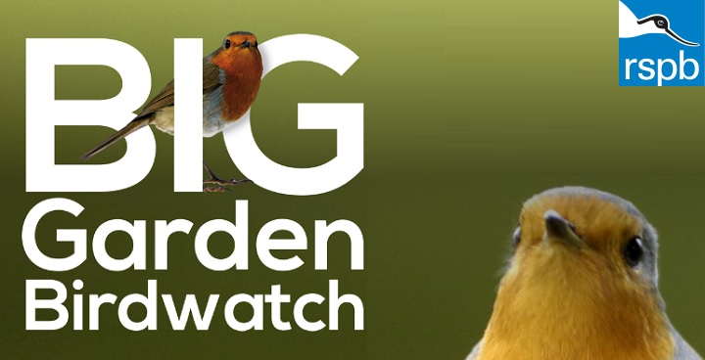 | Get your child involved with nature by taking part in the ‘Big Garden Birdwatch’, run by the RSPB.  Simply choose an hour between 28 and 30 January and count the birds that you see land in your garden, local park or from your balcony. After, log on to the RSPB website and let them know what you saw.  There are some lovely ideas on their website about getting children involved such as how to create DIY bird feeders or homemade bird cake.

Thank you for your ongoing support and if you have any questions or concerns that you would like to talk to me about, please do not hesitate to catch me at the classroom door or contact the school office to arrange an appointment.

Miss Hargreaves

