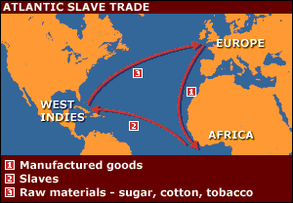
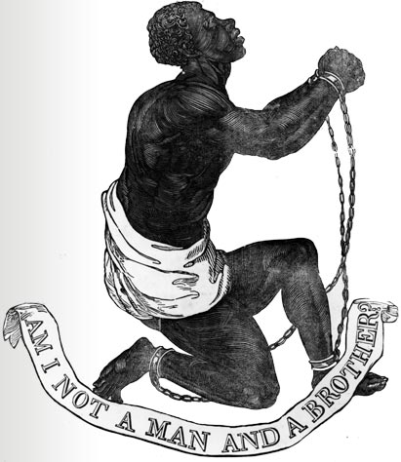
Y6 Spring Term Homework
The Slave Trade

Your project this half term is to research the history of the Slave Trade.
I would like you to find out:
- When and why it started
- Which countries were involved
- Where the slaves were taken from and to
- How the slaves were transported
- How the slaves were treated – what kind of jobs did they have?
- How slavery evolved in the Americas
You might also want to look in to how long this process lasted and why it finally ended!

Good Luck!
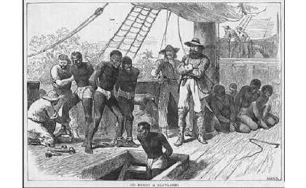
Please have your presentation ready by Wednesday 26th March – which is the last week of this half term!

