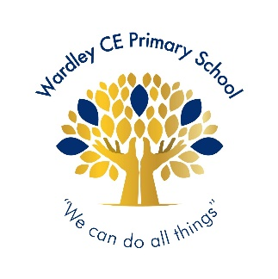**Wardley CE Primary School**

**‘With God’s love we enjoy and excel’**

**Celebration -Shout Out**

|  |  |
| --- | --- |
| **Nursery** | **Aleia** |
| **Reception** | **Mollie** |
| **Year 1** | **Lenny** |
| **Year 2** | **Unique-Praise** |
| **Year 3** | **Harlie** |
| **Year 4** | **Eva** |
| **Year 5** | **Finn** |
| **Year 6** | **Ava E** |



|  |  |
| --- | --- |
| **Year 1** | **David** |
| **Year 2** | **Lucas** |
| **Year 3** | **Emily** |
| **Year 4** | **Jeevan** |
| **Year 5** | **Mila** |
| **Year 6** | **Freddie** |



**Handwriter of the Week**

|  |
| --- |
| For thinking about everyone’s right to learn. |
| Year 1 – Ayda, Rory, Stanley, Lottie, Penny, Lenny, Hudson N, Oliver, Tommy, Saul, Hudson B, Noel, Poppy |
| Year 2 – Noah, George, Anaya, Lucas, Evelyn, Anna, Johanna, Lily, Kavin, Alfie, Daisy |
| Year 3 – Olivia, Oakley, Mia, Emily, Reece, Anais, Holly, Alex, Sienna, Oscar, Jude, Matilda, Harlie, Megan |
| Year 4 – Kuidrian, Leah, Georgie, Lottie, Lyanna, Prescious-Jewel, Mia, Alex |
| Year 5 – Seth, Niamh, Oscar Sn, Lola, Theo |
| Year 6 – Freddie, Vincy, Alexis, Ava E, Ava-Leigh, Beckett, Eleanor, Oscar |

**Jigsaw Stars**

**Headteacher’s Special Awards**

***Year 1: Mirha and Breyah for being super scientists.***

***Year 3: Willow & Roman for their great listening and learning.***

***Olivia for her fabulous RE work about God.***

***Alecia for being a PE superstar.***

***Year 4: Koby for being kind and sensible at swimming.***

***Year 5: Mila for her super writing when writing a formal letter.***

***Year 6: Gabriel for his superb contributions to all class discussions.***

***Anna for her outstanding maths work.***