Dear Parent and Carers,
Year 6 Newsletter
Autumn Term 2
Welcome back after the half term break!
I am very much looking forward to meeting you at Parents’ Evening to discuss your child’s progress so far this year and to discuss what we can do to help them progress even further. I am extremely pleased with the standard and effort that the children are putting in to their everyday achievements at the moment and I hope that this will continue over this busy half term. At the Curriculum Evening, I spoke about the CGP revision books that I am happy to order to assist the children with their SAT revision and to generally support their learning in Year 6. I will hand out the order forms at parents’ evening so that we can discuss any queries or concerns before ordering.
Here are a few details of the curriculum we will be studying this half term:
Subject | Information
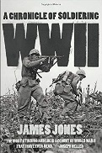  History | We will continue with our History topic of WWII. We will look at the evacuation of children from our cities and the different experiences of the evacuees. We will also look at rationing and the changing role of women. The children are thoroughly enjoying this topic and are looking forward to continuing their learning.
Science | Our Science for this half term is all about the classification of living things. The children will learn about the different groups of species, their common features and how these can be used to sort and group them.
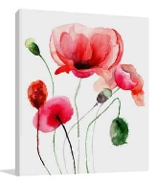  Art | Our Art project this half term is with our resident artist Mr Hall. The children have begun to sketch poppies and will continue to build their technical skills. Their project will be to create a cube with 3d poppies decorating it. These are sure to look fantastic and will be on display in the area outside our classroom.
PSHE | In PSHE our topic is Being me in my World. The children will be given time to reflect on pertinent aspects of their lives, both in and out of school. They will help each other to work co-operatively in a group as well as making other children feel valued and identify emotions such as happiness and fear.
PE | Mr Foster will take the children for their PE lessons on a Friday afternoon. Please ensure kits are in each week and that suitable warm clothing is sent in as the weather changes. He will teach the children games skills and the lacrosse coach will continue to teach the children this sport.
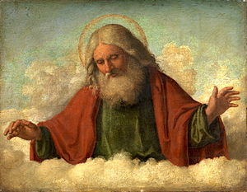  RE | In RE, the children will focus on Christianity and Islam. They will look at the similarities and differences between the two religions and reflect upon their own spirituality and beliefs.  The children will also look at generosity and how we can act generously towards others.
English  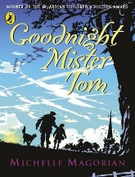 | In English, we will continue to read Goodnight Mister Tom and use this to stimulate our writing. The children will produce a mixture of fiction and non-fiction pieces and will focus on specific skills to help improve the technicality of their work. Alongside this, the first 20 minutes of each lesson will be designated to Spelling and grammar.
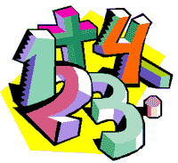  Maths | This term’s Maths’ lessons will be taught through Singapore Maths and will deepen the children’s knowledge and capability of Place Value, Addition, Subtraction, long multiplication, long division and fractions. Please ensure that you child regularly practices their times tables as a solid understanding and quick recall of the tables is vital. The children will also develop their reasoning skills and how to approach more challenging problems as well as developing their arithmetic skills.

Children will be given the following homework:
Subject | Content
Reading | Children should read at home (independently or with an adult) at least 3 times per week. They have been allocated with a reading book and have successfully logged on to, ‘My Book Blog’. Online they can complete related comprehension questions and develop their vocabulary skills. Opportunities to go online will be offered in school to those who do not have access at home.
Spelling | Spellings will be sent home every Monday and will be tested the following Friday. Please help your child to learn their weekly spellings and ensure that they write appropriate and challenging sentences.
Maths | Times tables will be tested every Friday. Pupils in year 6 are expected to answer 100 times tables within 3 minutes.  The children also have their Times Tables Rock Stars log ins.
Project | This half term, the children are invited to create a project at home. The theme is Save Our Planet. They may research any global issue from recycling to pollution…the choice is theirs. Please have the project ready for Wednesday 11th December.
Website | Please have a browse, with your child, at all the exciting things on our new website. We have loads of blogs and photos about all the goings on in Year 6. Log on to www.wardleyce.co.uk

Please help your child to learn their spellings and times tables as this will ensure that they are working in line with the national expectations. We have found that children who have the opportunity to consolidate their learning, with friends or family, make the most significant progress.
Please also ensure your child brings their book bag, complete with reading book to school each and every day.

If you would like to discuss any concerns, or share something positive, then feel free to come and see me at any time. My door is always open.

I look forward to seeing you at parents evening next week.

Kind Regards
Mrs K Walker
Year 6 Class Teacher/Deputy Head

