Year 1
Summer 1 Homework Project
The children are invited to take part in a history project to support their learning. They are looking at the lives of David Attenborough and Mary Anning.

Fossil Crafts  Using clay or plaster, create fossil imprints of shells or toy dinosaurs, painting them once they are dry.  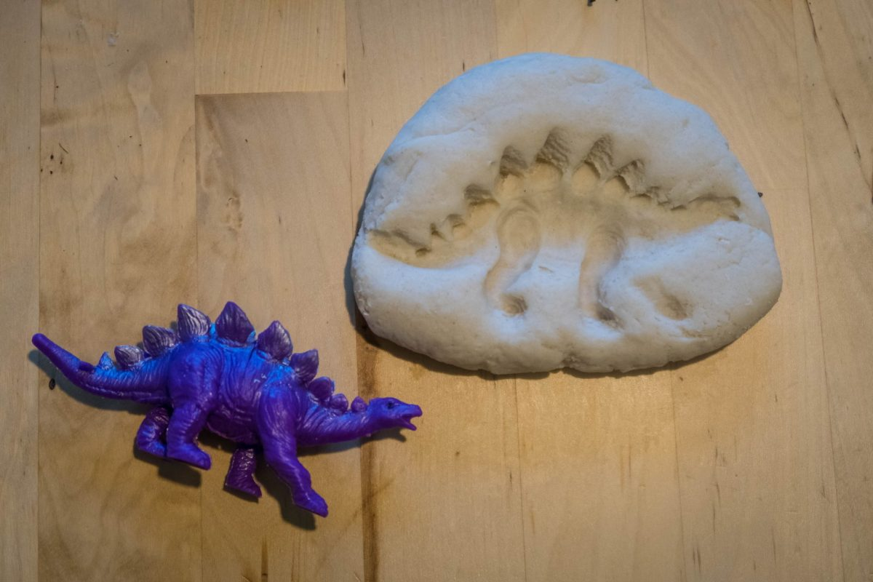 | Nature journal  Keep a nature journal for a week, drawing or pasting leaves, flowers or sketches of animals, much like David Attenborough’s insightful observations.  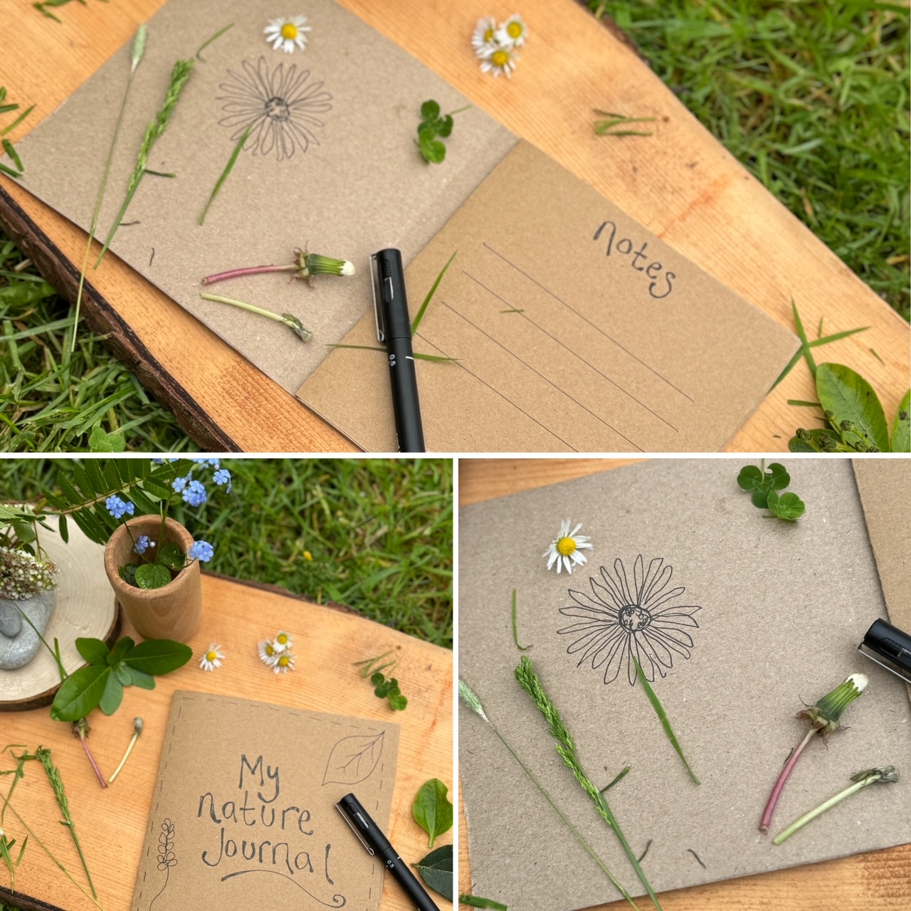 | Miniature Museum Exhibit  This could either feature Mary Anning’s Fossils or David Attenborough’s wildlife.  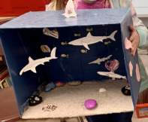

I look forward to seeing your super projects on Thursday 22nd May. | You could create your own fantastic idea. Just make sure it is related to the topic.

